OFFERTORY HYMN
“Ave Maria”: chant in the Music Issue

OFFERTORY ANTIPHON (choir)
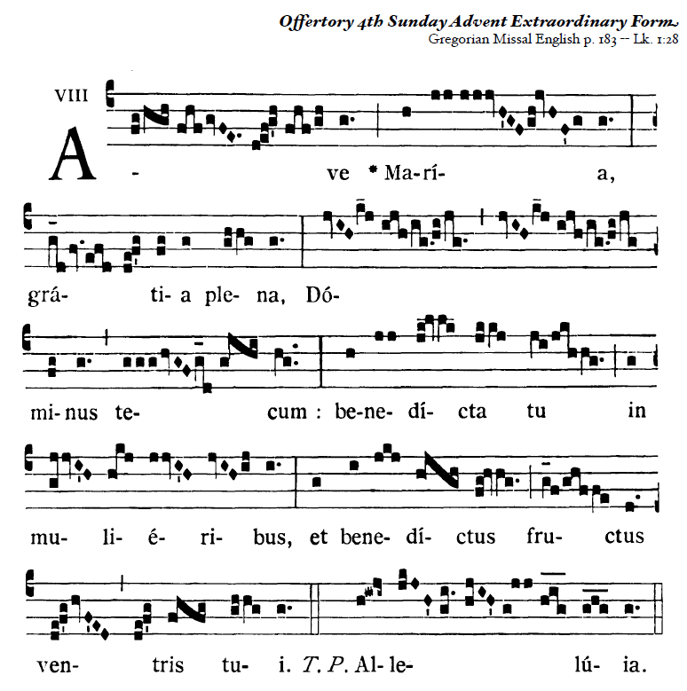

COMMUNION HYMN “ O Holy Mary” Music Issue

RECESSIONAL HYMN
Come, Thou Long-Expected Jesus

English antiphons from ©Illuminare Publications Adam Bartlett

F O U R T H S U N D A Y of A D V E N T

PRELUDE

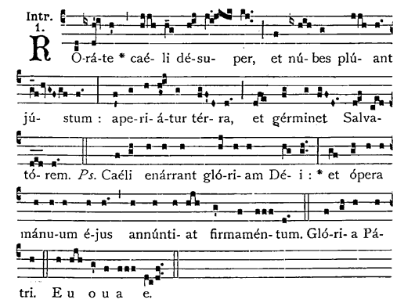

Drop down dew from heaven above, and let the clouds rain down the Just One; let the earth be openedand bring forth a Savior.

ENTRANCE ANTIPHON

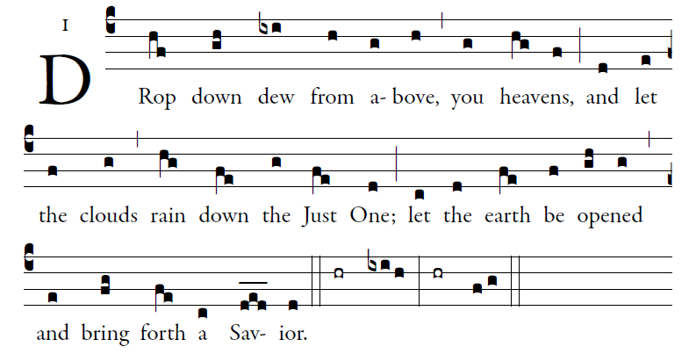

The heavens declare the glory of God,
and the firmament proclaims the work of his hands.
Day unto day conveys the message,
and night unto night imparts the knowledge.

No speech, no word, whose voice goes unheeded;
their sound goes forth through all the earth,
their message to the utmost bounds of the world.

There he has placed a tent for the sun;
it comes forth like a bridegroom coming from his tent,
rejoices like a champion to run his course.

Ordinary of the Mass : ICEL chant Mass
Found in Today’s Missal

RESPONSORIAL PSALM year C

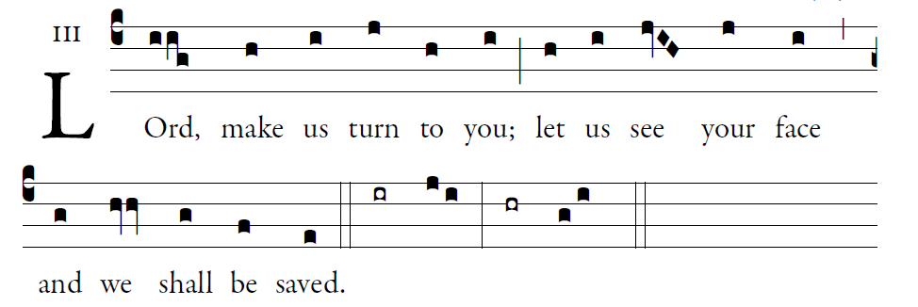

O shepherd of Israel, hearken,
from your throne upon the cherubim, shine forth.
Rouse your power,
and come to save us.
Once again, O LORD of hosts,
look down from heaven, and see;
take care of this vine,
and protect what your right hand has planted
the son of man whom you yourself made strong.
May your help be with the man of your right hand,
with the son of man whom you yourself made strong.
Then we will no more withdraw from you;
give us new life, and we will call upon your name.

