RECESSIONAL HYMN

“Sing With All he Saints in Glory”

3. Life eternal! heaven rejoices;
Jesus lives, who once was dead
Join we now the deathless voices;
child of God, lift up your head!
Patriarchs from the distant ages,
saints all longing for their heaven,
prophets, psalmists, seers, and sages,
all await the glory given.
4. Life eternal! O what wonders
crowd on faith; what joy unknown,
when, amidst earth's closing thunders,
saints shall stand before the throne!
O to enter that bright portal,
see that glowing firmament;
know, with thee, O God Immortal,
"Jesus Christ whom thou has sent!"

ALL SAINTS

ENTRANCE HYMN “For All the Saints”

Ordinary of the Massis ICEL MASS in Today’s Missal withing the Mass prayers

RESPONSORIAL PSALM
Illuminarepublications.com

ALLELUIA
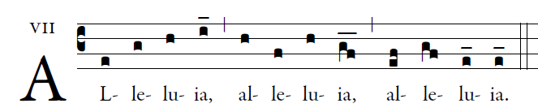
Come me to me all you who are labor and are burdned,
And I will give you rest says the Lord

OFFERTORY HYMN “We Are the Light of the World”

COMMUNION HYMN

“Rejoice for All the Saints this Day”
