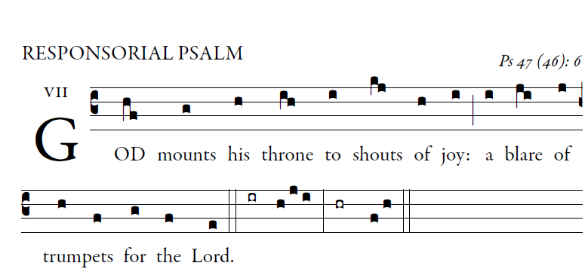

Illuminareppublications,com

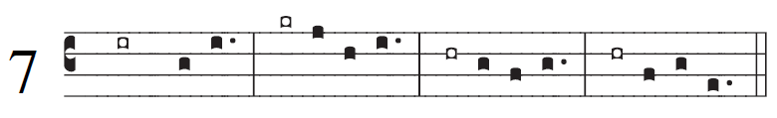

**Responsorial Psalm Ps 47:2-3, 6-7, 8-9**

All you peoples, clap*your hands,*  
shout to God with *cries of gladness,*  
For the LORD, the Most *High, the awesome,*  
is the great king over *all the earth.*

God mounts his throne amid shouts *of joy;*  
the LORD, amid *trumpet blasts.*  
Sing praise to *God, sing praise;*  
sing praise to our *king, sing praise.*  
  
For king of all the earth*is God;*  
sing *hymns of praise***.**  
God reigns ov*er**the nations,*  
God sits upon his *holy throne.*

