Lamb of God

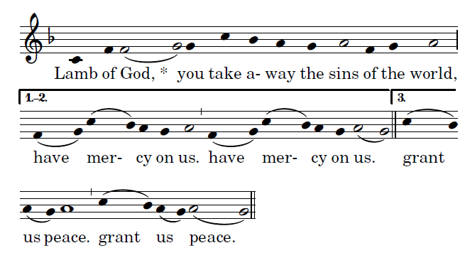

Communion Antiphon

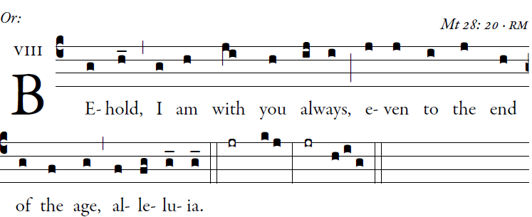
Illuminarepublications.com
Let God arise; let his |foes be scattered.
Let those who hate him flee |from his
presence.

O sing to God; make music to his name.
Extol the One who rides on the clouds.
The LORD is his name; exult at his
presence.
Father of orphans, defender of widows:
such is God in his holy place

Communion Hymn. “Be Not Afraid”

Recessional Hymn:
“Alleluia, Let the Holy Anthem Rise”

The Ascension of the Lord

Entrance Antiphon

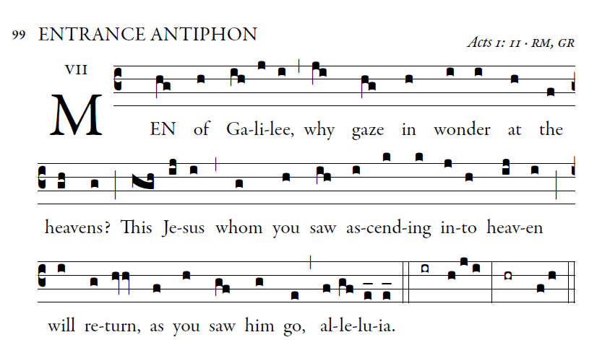

Illuminarepublications.com
Gloria
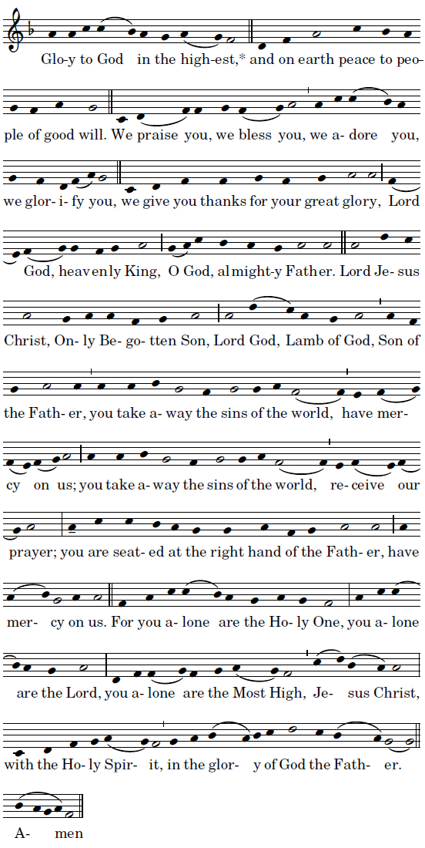

Mass ordinaries ©Richard Clark reprinted with permission

Responsorial Psalm
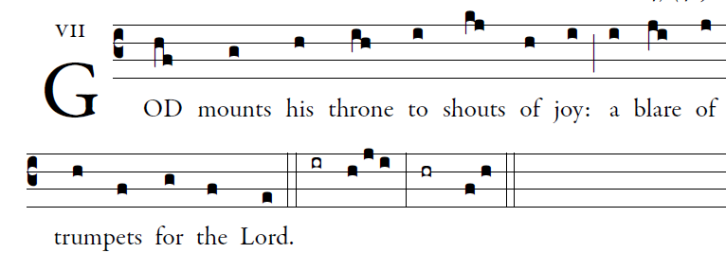
Illuminarepublications.com
All you peoples, clap your hands,
shout to God with cries of gladness,
For the LORD, the Most High, the awesome,
is the great king over all the earth.
God mounts his throne amid shouts of joy;
the LORD, amid trumpet blasts.
Sing praise to God, sing praise;
sing praise to our king, sing praise.
For king of all the earth is God;
sing hymns of praise.
God reigns over the nations,
God sits upon his holy throne.

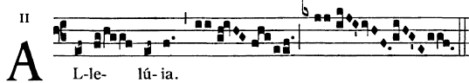

  Go and teach all nations, says the Lord;
I am with you always, until the end of the world.

Offertroy Hymn “ Glory and Praise For Ever”

Holy
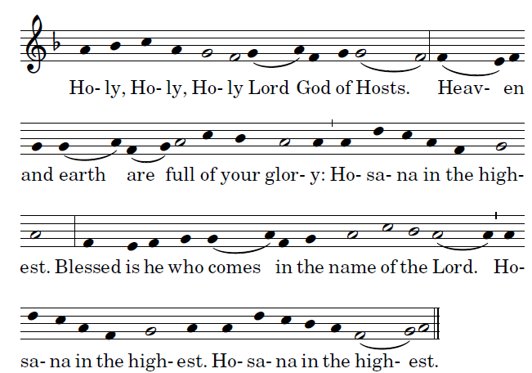

Acclamation
