RECESSIONAL HYMn

ALLLELUIA SING TO JESUS
Alleluia! not as orphans
are we left in sorrow now;
Alleluia! He is near us,
faith believes, nor questions how;
Though the cloud from sight received him
when the forty days were o'er
shall our hearts forget his promise,
'I am with you evermore'?
Alleluia! bread of heaven,
here on earth our food and stay!
Alleluia! here the sinful
flee to thee from day to day.
Intercessor, Friend of sinners,
earth's Redeemer, plead for me.
Where the songs of all the sinless
sweep across the crystal sea.

The Ascension of the Lord

ENTrance antiphon
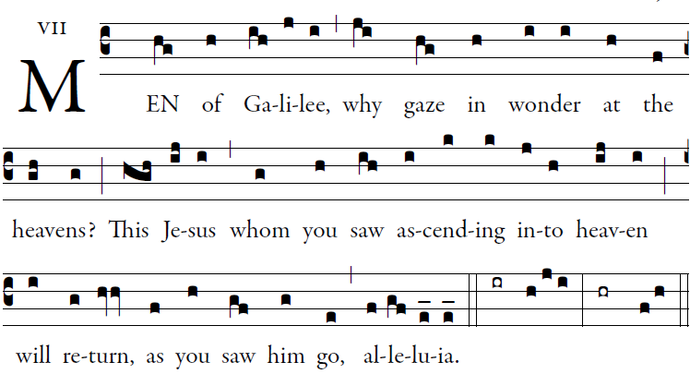

Illuminarepublications.com

All peoples, clap your hands.
Cry to God with shouts of joy!
For the lord, the Most High, is awesome,
the great king over all the earth.

He humbles peoples under us
and nations under our feet.
Our heritage he chose for us,
the pride of Jacob whom he loves.

God goes up with shouts of joy.
The Lord goes up with trumpet blast.
Sing praise for God; sing praise!
Sing praise to our king; sing praise!

Kyrie #20 TM Gloria #21

Responsorial Psalm Illuminarepublications.com
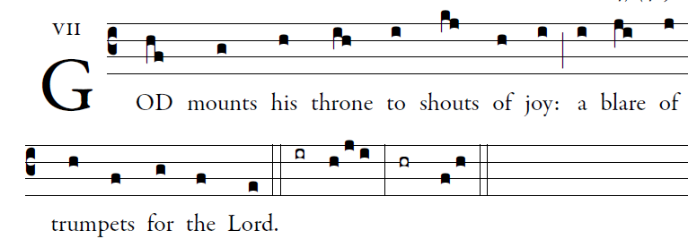

All you peoples, clap your hands,
shout to God with cries of gladness,
For the LORD, the Most High, the awesome,
is the great king over all the earth.

God mounts his throne amid shouts of joy;
the LORD, amid trumpet blasts.
Sing praise to God, sing praise;
Sing praise to God, sing praise;

For king of all the earth is God;
sing hymns of praise.
God reigns over the nations,
God sits upon his holy throne.

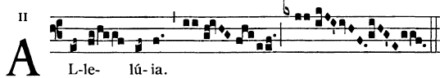

  Go and teach all nations, says the Lord;
I am with you always, until the end of the world.

HOLY #26

OFFERTORY HYMN

Alleluia! Alleluia! Let the Holy Anthemn Rise

COMMUNION ANTIPHON

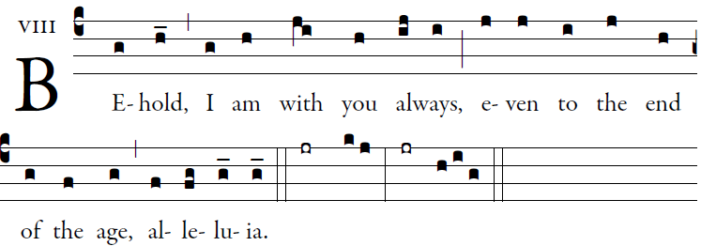

Let God arise; let his foes be scattered.
Let those who hate him flee from his presence.

O sing to God; make music to his name.
Extol the One who rides on the clouds.
The LORD is his name; exult at his presence.
Father of orphans, defender of widows:
such is God in his holy place

You have ascended on high;
leading captiveity captive
as tribute receiving prisoners, O God,
so that even rebels may dwell near the LORD God.
Day after day, may the LORD be blest.
He bears our burdens; God is our savior.

This God of ours is a God who saves.
The LORD our LORD provides an escape from death.
Summon forth your might, O God;
your might, O God, which you have shown for us.

