COMMUNION ANTIPHON

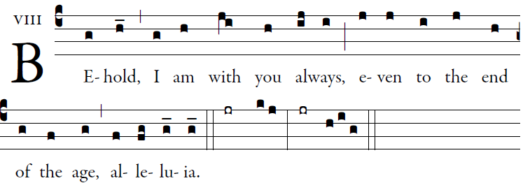 Illuminarepublications.com
Let God arise; let his foes be scattered.
Let those who hate him flee from his presence.

O sing to God; make music to his name.
Extol the One who rides on the clouds.
The LORD is his name; exult at his presence.
Father of orphans, defender of widows:
such is God in his holy place

You have ascended on high; 6
leading captiveity captive
as tribute receiving prisoners, O God
so that even rebels may dwell near the God.
Day after day, may the LORD be blest.
He bears our burdens; God is our savior.

RECESSIONAL HYMN

“ Alleluia, Let The Holy Anthem Rise”

THE ASCENSION OF THE LORD

ENTRANCE ANTIPHON
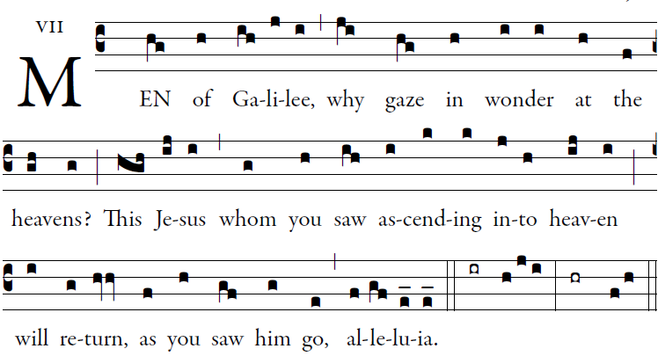

Illuminarepublications.com

All peoples, clap your hands.
Cry to God with shouts of joy!
For the Lord, the Most High, is awesome,
the great king over all the earth.

He humbles peoples under us
and nations under our feet.
Our heritage he chose for us,
the pride of Jacob whom he loves.

God goes up with shouts of joy.
The Lord goes up with trumpet blast.
Sing praise for God; sing praise!
Sing praise to our king; sing praise!

Responsorial Psalm Illuminarepublications.com
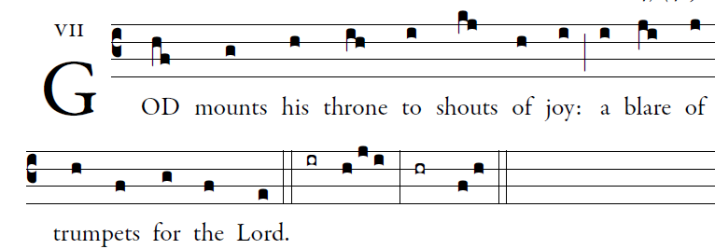

All you peoples, clap your hands,
shout to God with cries of gladness,
For the LORD, the Most High, the awesome,
is the great king over all the earth.

God mounts his throne amid shouts of joy;
the LORD, amid trumpet blasts.
Sing praise to God, sing praise;
Sing praise to God, sing praise;

For king of all the earth is God;
sing hymns of praise.
God reigns over the nations,
God sits upon his holy throne.

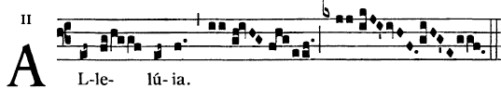

      Go and teach all nations, says the Lord;
I am with you always, until the end of the world.

OFFERTORY HYMN

Let the Earth rejoice and sing Llanfair

Let the earth rejoice and sing, alleluia!
At the triumph of our King, alleluia!
He ascends from mortal sight, alleluia!
Reigns now at our Father’s right, alleluia!

He who died upon a tree, alleluia!
Now shall reign eternally, alleluia!
He who saved our fallen race, alleluia!
Takes in heav’n his rightful place, alleluia!

Jesus, Lord, all hail to thee, alleluia!
On this day of victory, alleluia!
Thou didst shatter Satan’s might, alleluia!
Rising glorious from the fight, alleluia!

Jesus, Victor, hear our prayer, alleluia!
In thy triumph let us share, alleluia!
Lift our minds and hearts above, alleluia!
Strengthen all men in thy love, alleluia!

