COMMUNION HYMN:
“Godhead Here in Hiding” Adoro Te
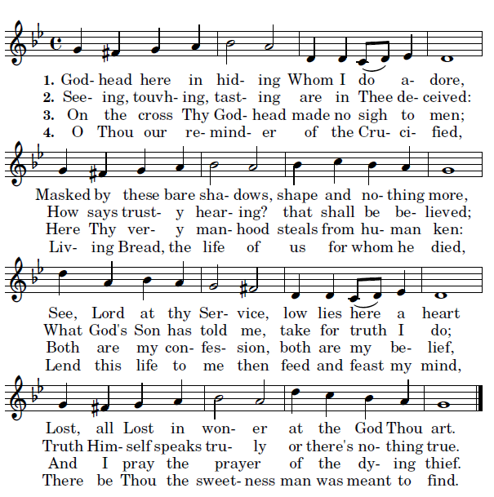

Jesus whom I look at shrouded here below
I beseech Thee, send me what I thirst for so,
Some day to gaze on Thee face to face in light
And be blest forever with Thy glory’s sight.

RECESSIONAL HYMN:
“Parce Domine”

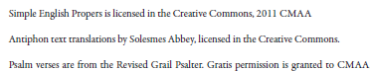

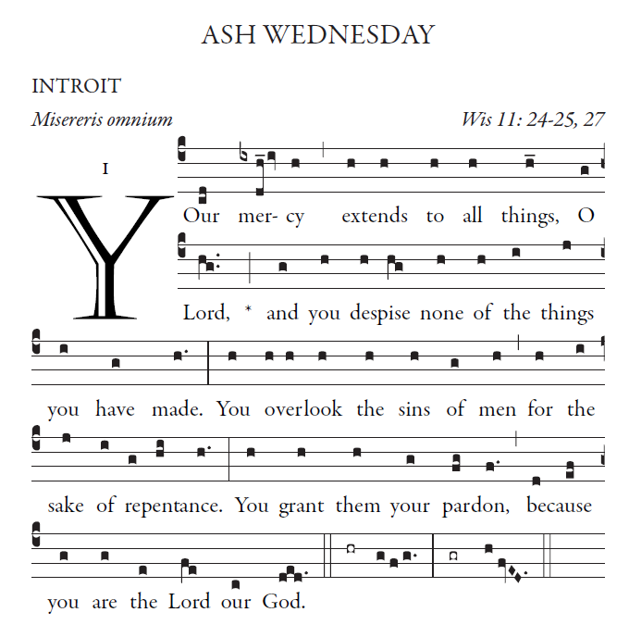
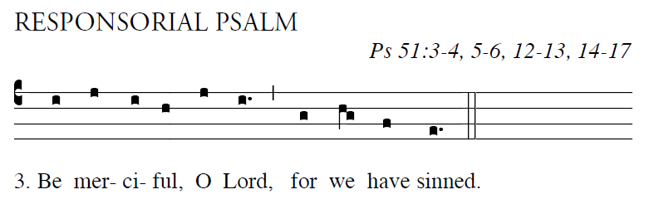
= Have mercy on me, O God, in your goodness;
in the greatness of your compassion wipe out my of-fense.
Thoroughly wash me from my guilt
and of my sin cleanse me.  

For I acknowledge my of-fense,
and my sin is be-fore me always:
“Against you only have I sinned,
and done what is evil in your sight.”  

A clean heart create for me, O God,
and a steadfast spirit re-new with-in me.
Cast me not out from your presence,
and your Holy Spirit take not from me.  

Give me back the joy of your sal-vation,
and a willing spirit sus- tain in me.
O Lord, open my lips,
and my mouth shall proclaim your praise.  

VERSE BEFORE THE GOSPEL
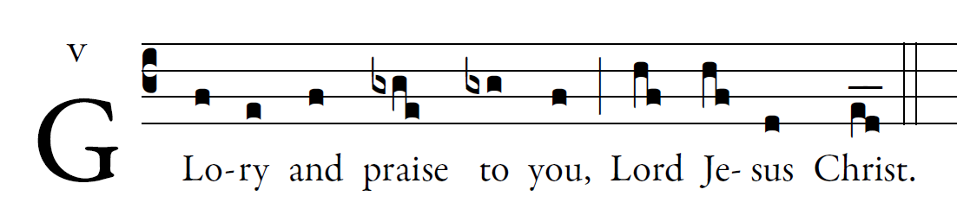
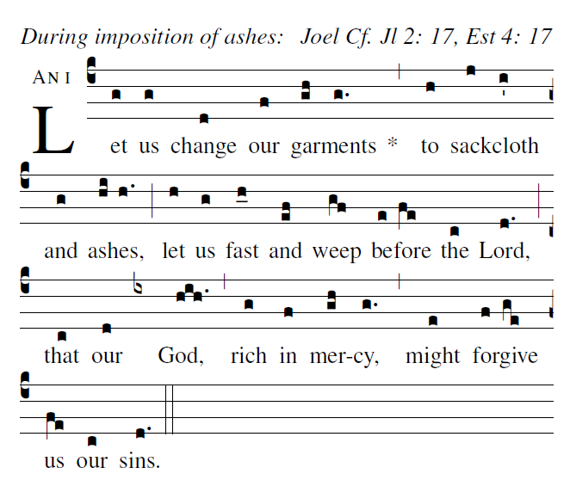

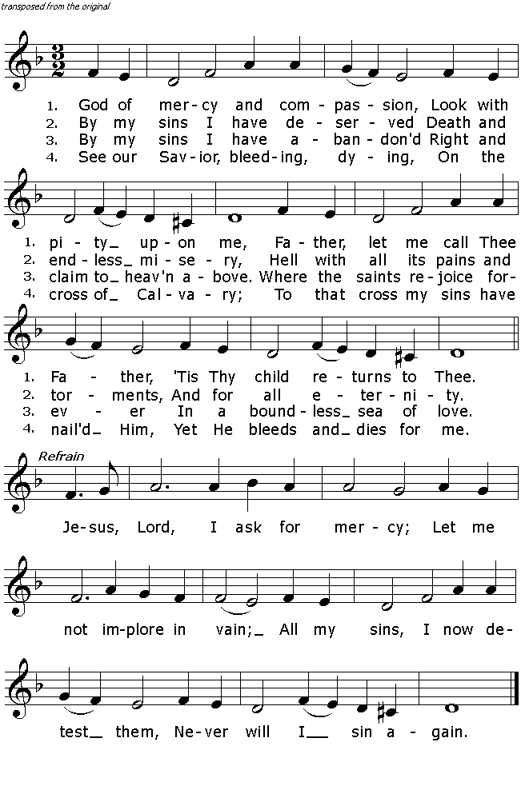
OFFERTORY HYMN: “Attende Domine” Todays Missal

