COMMUNION ANTIPHON:
© ILLUMINAREPUBLICATION.COM
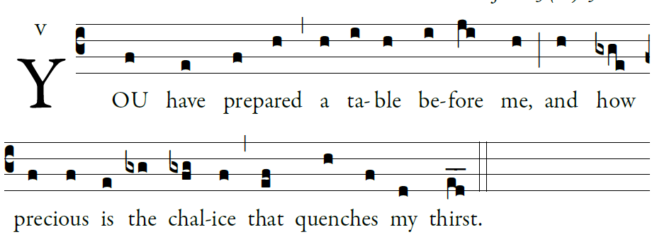

The LORD is my shepherd;
there is nothing I shall want.
²Fresh and green are the pastures
where he gives me repose.
Near restful waters he leads me;
³he revives my soul.
He guides me along the right path,
for the sake of his name.
Though I should walk in the valley of the shadow of death,
no evil would I fear, for you are with me.
Your crook and your staff will give me comfort.

You have prepared a table before me
in the sight of my foes.
My head you have anointed with oil
my cup is overflowing.




