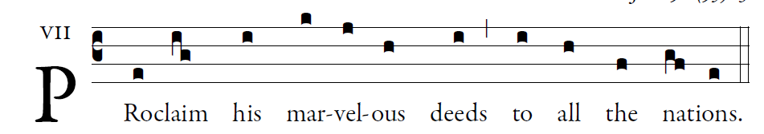

Sing to the LORD a new song;
sing to the LORD, all you lands.
Sing to the LORD; 

Announce his salvation, day after day.
Tell his glory among the nations;
among all peoples, his wondrous deeds.  
Give to the LORD, you families of nations,
give to the LORD glory and praise;
give to the LORD the glory due his name! 

Worship the LORD in holy attire.
Tremble before him, all the earth;
Say among the nations: The LORD is king.
He governs the peoples with equity. 

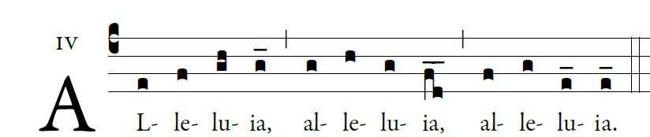

  God has called us through the Gospel /to possess the glory of our Lord Jesus Christ

