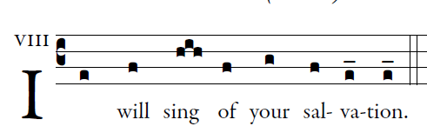

illuminare publicatiaons.com

In you, O LORD, I take refuge;
let me never be put to shame.
In your justice rescue me, and deliver me;
incline your ear to me, and save me.
Be my rock of refuge,
a stronghold to give me safety,
for you are my rock and my fortress.
O my God, rescue me from the hand of the wicked.
For you are my hope, O Lord;
my trust, O God, from my youth.
On you I depend from birth;
from my mother’s womb you are my strength.
My mouth shall declare your justice,
day by day your salvation.
O God, you have taught me from my youth,
and till the present I proclaim your wondrous deeds.

