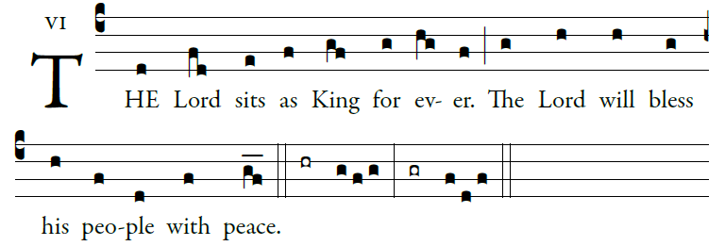
©Illuminarepublication.com
©Saint Meinrad Archabbey

Ascribe to the LORD, you heav - enly powers,
ascribe to the LORD glory and strength.
Ascribe to the LORD the glory of his name;
bow down before the LORD, majes - tic in holiness.

The voice of the LORD up - on the waters, [6]
the God of glory thunders;
⁴the LORD on the immensity of waters;
⁵ the voice of the LORD full of power;
⁶ the voice of the LORD full of splendor

¹The voice of the LORD flashes flames of fire.
² The voice of the LORD shakes the wilderness,
⁴the LORD shakes the wilder - ness of Kadesh;

¹ the voice of the LORD rends the oak tree
²and strips the forest bare.
⁴ In his temple they all cry, “Glory!”
