RECESSIONAL HYMN:

“JESUS MY LORD, MY GOD, MY ALL”

Jesus, my Lord, my God, my all!
How can I love Thee as I ought?
And how revere this wondrous gift,
So far surpassing hope or thought?
Refrain

Sweet Sacrament, we Thee adore!
Oh, make us love Thee more and more.
Oh, make us love Thee more and more.

2. Had I but Mary's sinless heart
With which to love Thee, dearest King,
Oh, with what ever fervent praise,
Thy goodness, Jesus, would I sing!

Refrain
Sweet Sacrament, we Thee adore!
Oh, make us love Thee more and more.
Oh, make us love Thee more and more.

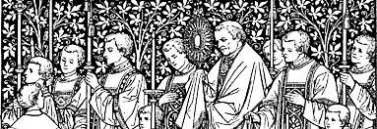
The Solemnity of theMost Holy Body and Blood of Christ
YEAR A

ENTRANCE ANTIPHON

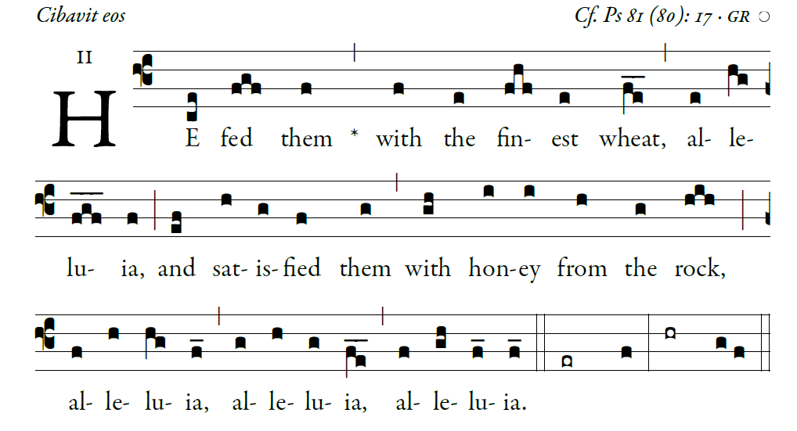
©Illuminare Publications.com

Sing joyfully to God our strength,
shout in triumph to the God of Jacob.
Raise a song and sound the timbrel,
the sweet-sounding harp and the lute;

Blow the trumpet at the new moon,
when the moon is full, on our feast.
For this is a statute in Israel,
a command of the God of Jacob.

I am the LORD your God,
who brought you up from the land of Egypt.
Open wide your mouth, and I will fill it.

The Lord Have Mercy and Gloria are found the
Yellow program ORBIS FACTOR MASS XI

RESPONSORIAL PSALM
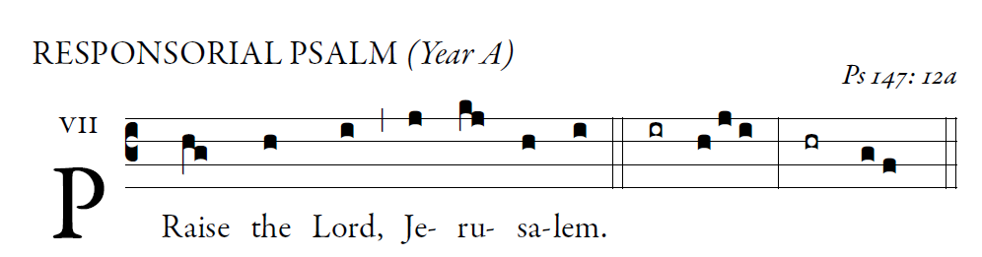
Glorify the LORD, O Jerusalem;
praise your God, O Zion.
For he has strengthened the bars of your gates;
he has blessed your children within you.
   Praise the Lord, Jerusalem.
He has granted peace in your borders;
with the best of wheat he fills you.
He sends forth his command to the earth;
swiftly runs his word!
   Praise the Lord, Jerusalem.
He has proclaimed his word to Jacob,
his statutes and his ordinances to Israel.
He has not done thus for any other nation;
his ordinances he has not made known to them. Alleluia   Praise the Lord, Jerusalem.
SEQUENCE Laud, O Sion Your Salvation

ALLELUIA
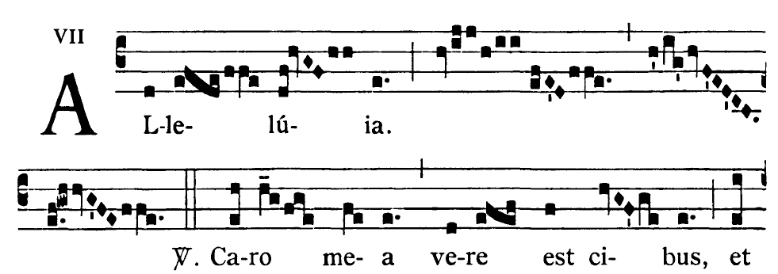

 I am the living bread that came down from heaven,
says the Lord;
whoever eats this bread will live forever

OFFERTORY HYMN : “Godhead Here in Hiding”

“Holy,” and “Lamb of God” are found in the
Yellow program : MASS XI ORBIS FACTOR

COMMUNION ANTIPHON 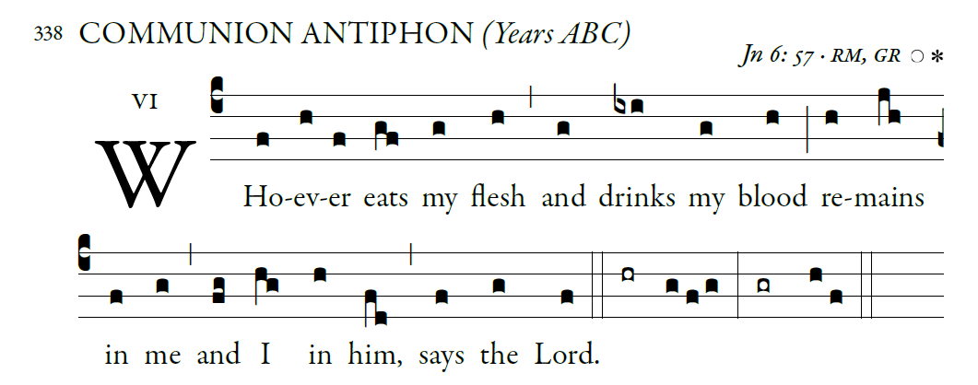
Fr. Columba Kelly ©Saint Meinrad Archabbey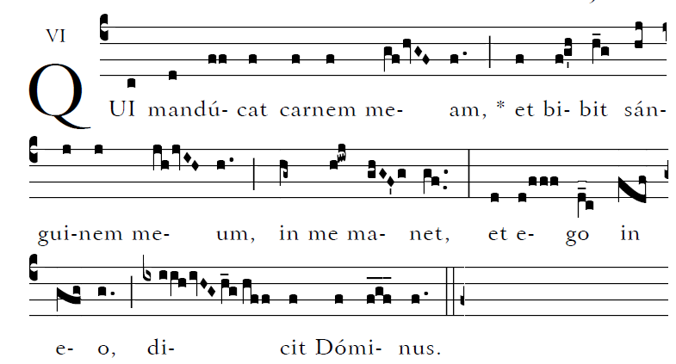

Blessed are those whose way is blameless,
who walk in the law of the LORD!
²Blessed are those who keep his decrees!
With all their hearts they seek him

