Communion Hymn
“Jesus.My Lord,My Gofd, My All”

1 Jesus, my Lord, my God, my All,
How can I love thee as I ought?
And how revere this wondrous gift,
So far surpassing hope or thought?
Sweet Sacrament, we thee adore;
Oh, make us love thee more and more.
Oh, make us love thee more and more.

2 Had I but Mary's sinless heart
To love thee with, my dearest King,
Oh, with what bursts of fervant praise
Thy goodness, Jesus, would I sing.
Sweet Sacrament, we thee adore;
Oh, make us love thee more and more.
Oh, make us love thee more and more.

3 Thy Body, Soul, and Godhead, all,
O mystery of love divine.
I cannot compass all I have,
For all thou hast and art are mine.
Sweet Sacrament, we thee adore;
Oh, make us love thee more and more.
Oh, make us love thee more and more

RECESSIONAL HYMN
“Holy God, We Praise thy Name”
#775 WORD &SONG

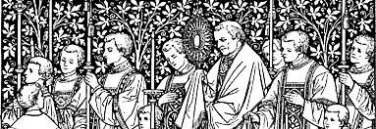
The Solemnity of the Most Holy Body and Blood of Christ

ENTRANCE ANTIPHON

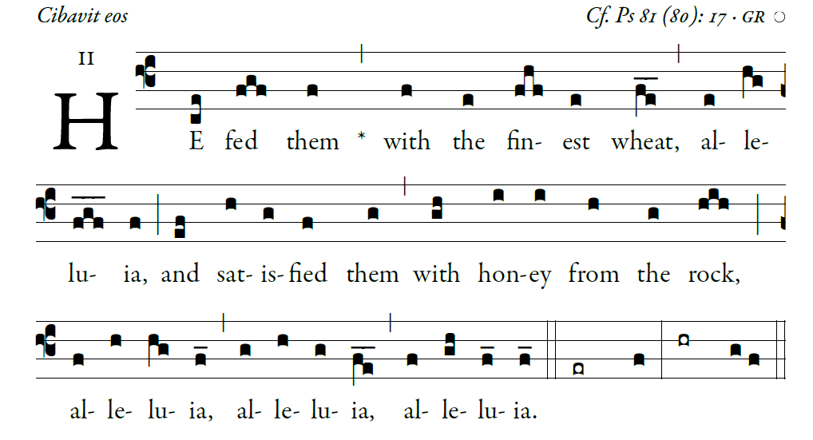
©Illuminare Publications.com

Sing joyfully to God our strength,
shout in triumph to the God of Jacob.
Raise a song and sound the timbrel,
the sweet-sounding harp and the lute;

Blow the trumpet at the new moon,
when the moon is full, on our feast.
For this is a statute in Israel,
a command of the God of Jacob.

I am the LORD your God,
who brought you up from the land of Egypt.
Open wide your mouth, and I will fill it.

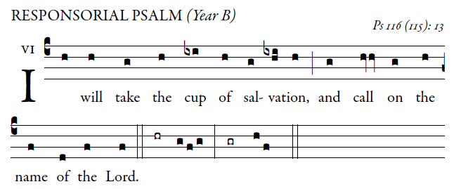

1. How can I repay the Lord

for all his goodness to me?
The cup of salvation I will raise;
I will call on the name of the Lord.

2. How precious in the eyes of the Lord
is the death of his faithful.
the son of your handmaid;
you have loosened my bonds.

3. A thanksgiving sacrifice I make;
I will call on the name of the Lord.
My vows to the lord I will fulfill.
before all his people,

ALLELUIA.
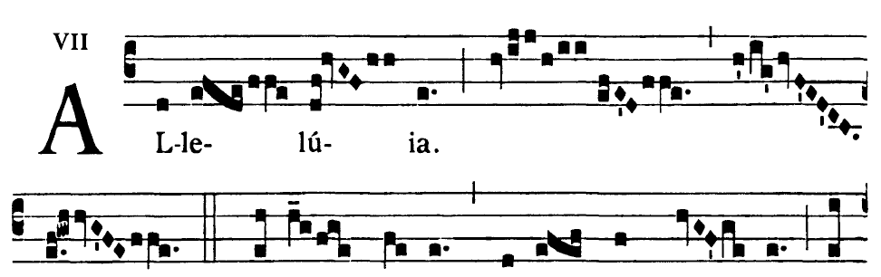
= I am the living bread that came down
from heaven, says the Lord;
whoever eats this bread will live forever.

OFFERTORY HYMN

“O FOOD TO PILGRIMS GIVEN”

