COMMUNION ANTIPHON

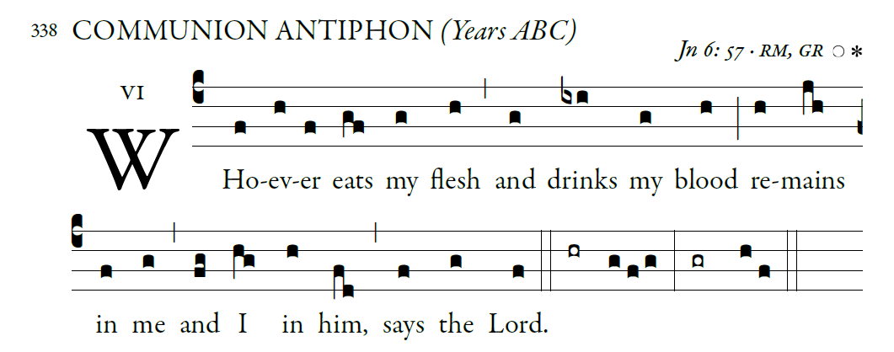

**Fr. Columba Kelly. Saint Meinrad Archabbey**

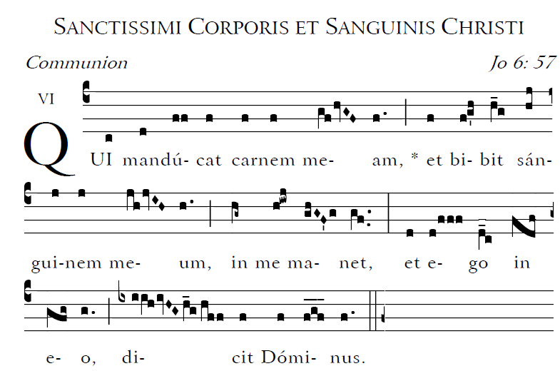

**Communion Hymn : “Tantum Ergo”**

*inside the back cover of Today’s Missal*

RECESSIONAL HYMN:

“Jesus , My Lord, My God, My All”

Music Issue #669

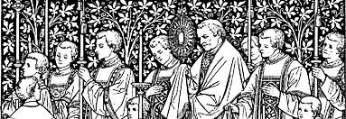

The Solemnity of the Most Holy Body and Blood of Christ

ENTRANCE ANTIPHON

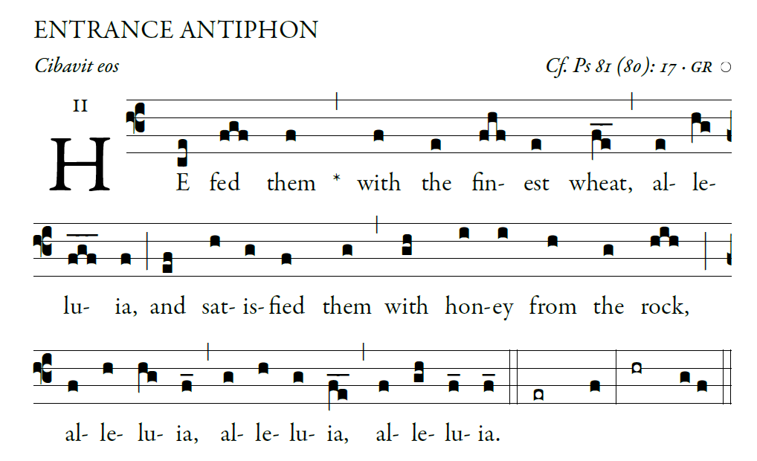

**©Illuminare Publications.com**

Sing joyfully to God our strength,

 shout in triumph to the God of Jacob.

 Raise a song and sound the timbrel,

 the sweet-sounding harp and the lute;

 Blow the trumpet at the new moon,

 when the moon is full, on our feast.

For this is a statute in Israel,

 a command of the God of Jacob.

I am the LORD your God,

 who brought you up from the land of Egypt.

 Open wide your mouth, and I will fill it.

RESPONSORIAL PSALM

RB2016

**

The LORD said to my Lord:

**"Sit at my right hand  
 till I make your enemies your footstool." **

The scepter of your power the LORD

will stretch forth from Zion: **"Rule in the midst of your enemies."   **

**"Yours is princely power in the day of your birth,**

**in holy splendor; before the daystar,**

**like the dew, I have begotten you." **

The LORD has sworn, and he will not repent: **"You are a priest forever,**

**according to the order of Melchizedek."         **

ALLELUIA.

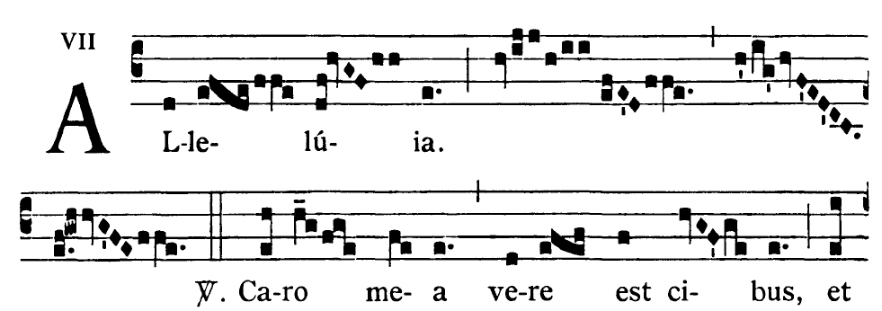

**= I am the living bread that came down**

**from heaven,** says the Lord;  
**whoever eats this bread will live forever.**

OFFERTORY HYMN

“O FOOD TO PILGRIMS GIVEN”

