RECESSIONAL HYMN:

“JESUS MY LORD, MY GOD, MY ALL”

Jesus, my Lord, my God, my all!
How can I love Thee as I ought?
And how revere this wondrous gift,
So far surpassing hope or thought?
Refrain

Sweet Sacrament, we Thee adore!
Oh, make us love Thee more and more.
Oh, make us love Thee more and more.

2. Had I but Mary's sinless heart
With which to love Thee, dearest King,
Oh, with what ever fervent praise,
Thy goodness, Jesus, would I sing!

Refrain
Sweet Sacrament, we Thee adore!
Oh, make us love Thee more and more.
Oh, make us love Thee more and more.

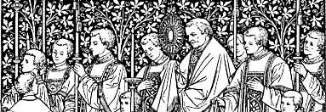
The Solemnity of the Most Holy Body and Blood of Christ
YEAR B

ENTRANCE ANTIPHON

Saint Meinrad Archabbey© 2012
Creative Commons Attribution-Noncommercial-No Derivative Works 3.0 United States License.

Sing joyfully to God our strength,
shout in triumph to the God of Jacob.
Raise a song and sound the timbrel,
the sweet-sounding harp and the lute;

Blow the trumpet at the new moon,
when the moon is full, on our feast.
For this is a statute in Israel,
a command of the God of Jacob.

I am the LORD your God,
who brought you up from the land of Egypt.
Open wide your mouth, and I will fill it.

RESPONSORIAL PSALM

Ps. 116:12-13, 15-16, 17-18
How shall I make a return to the LORD
for all the good he has done for me?
The cup of salvation I will take up,
and I will call upon the name of the LORD. +
Precious in the eyes of the LORD
is the death of his faithful ones.
I am your servant, the son of your handmaid;
you have loosed my bonds. +
To you will I offer sacrifice of thanksgiving,
and I will call upon the name of the LORD.
My vows to the LORD I will pay
in the presence of all his people. +
SEQUENCE Laud, O Sion Your Salvation

ALLELUIA
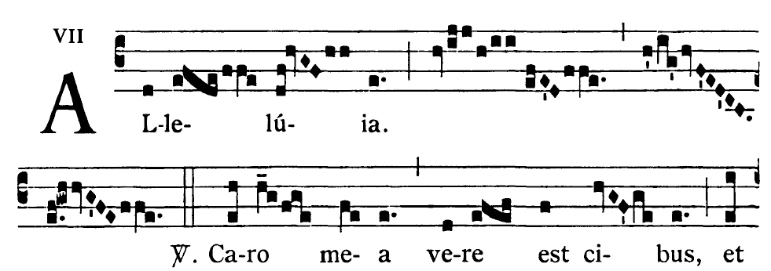

 I am the living bread that came down from heaven,
says the Lord; whoever eats this bread will live forever

OFFERTORY HYMN : “Godhead Here in Hiding”

COMMUNION ANTIPHON 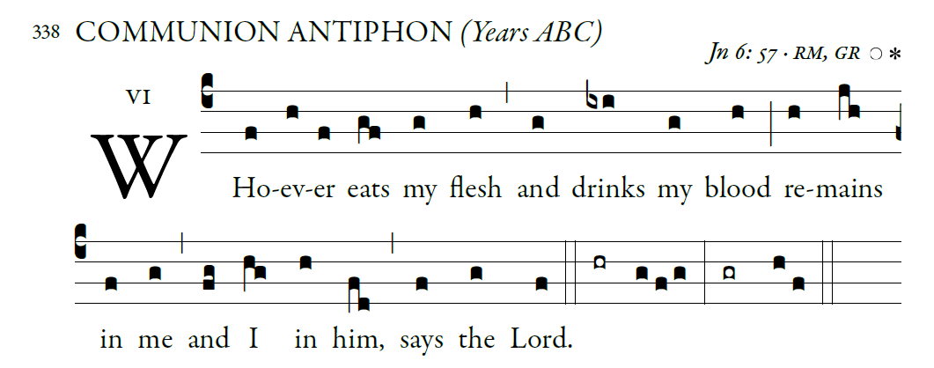
Saint Meinrad Archabbey© 2012
Creative Commons Attribution-Noncommercial-No Derivative Works 3.0 United States License.
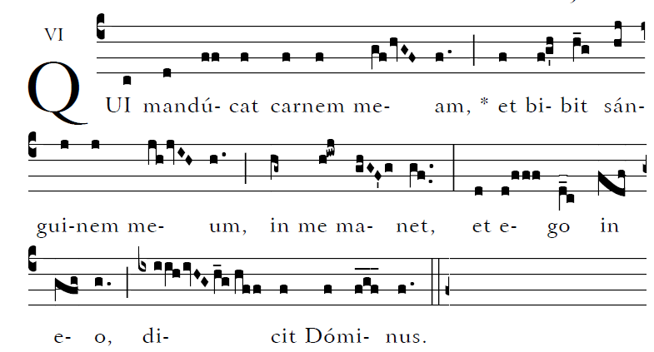

Blessed are those whose way is blameless,
who walk in the law of the LORD!
²Blessed are those who keep his decrees!
With all their hearts they seek him

