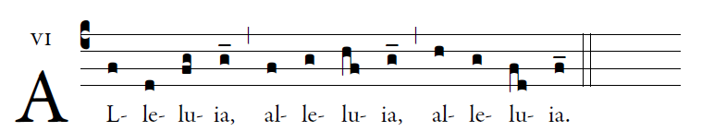

Sing joyfully to the LORD, all you lands;
serve the LORD with gladness;
come before him with joyful song.
 Alleluia.

Know that the LORD is God;
he made us, his we are;
his people, the flock he tends.
 Alleluia.

The LORD is good:
his kindness endures forever,
and his faithfulness, to all generations.
 Alleluia.

