RESPONSORIAL PSALM

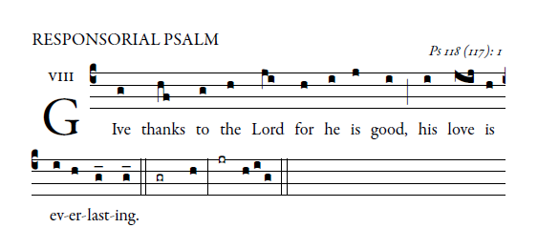
Let the house of Israel say,
“His mercy endures forever.”
Let the house of Aaron say,
“His mercy endures forever.”
Let those who fear the LORD say,
“His mercy endures forever.”
I was hard pressed and was falling,
but the LORD helped me.
My strength and my courage is the LORD,
and he has been my savior.
The joyful shout of victory
in the tents of the just:
The stone which the builders rejected
has become the cornerstone.
By the LORD has this been done;
it is wonderful in our eyes.
This is the day the LORD has made;
let us be glad and rejoice in it.

ALLELUIA
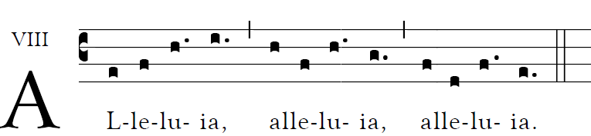

OFFERTORY HYMN “Ye Sons and Daughters” Today’s Missal

COMMUNION ANTIPHON

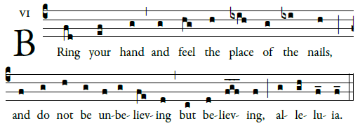

Give praise to the LORD, for he is good
his mercy endures forever.
Let the house of Israel say,
“His mercy endures forever.”

I called to the LORD in my distress;
he has answered and freed me.
It is better to take refuge in the LORD
than to trust in man;

I was thrust down, thrust down and falling,
but the LORD was my helper.
The LORD is my strength and my song;
he was my savior.

There are shouts of joy and salvation
in the tents of the just.
“The LORD’s right hand has done mighty deeds;
his right hand is exalted.

I will thank you, for you have answered,
and you are my savior.
The stone that the builders rejected
has become the cornerstone.

RECESSIONAL HYMN: Henryk Jan Botar
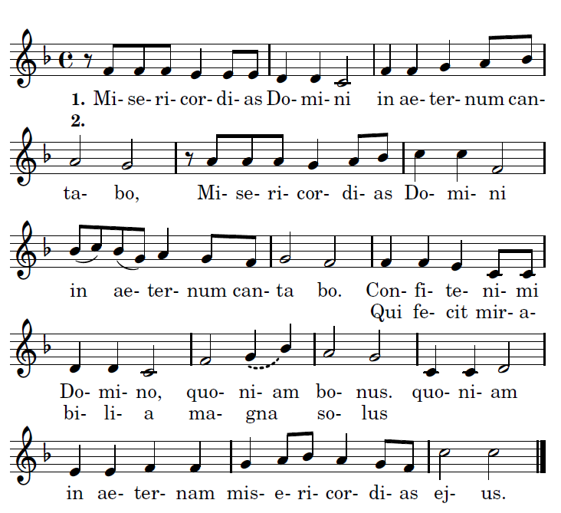

I will sing of the mercies of the Lord forever!
Give thanks to the Lord for he is good,
I will sing of the mercies of the Lord forever!
who alone has done marvelous deeds.

2017
proper antiphons $©$ illluminarepublications.co

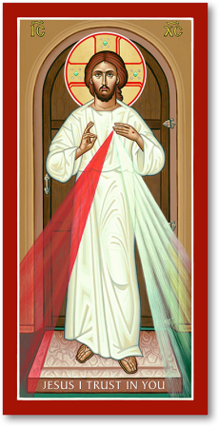
2nd SUNDAY of EASTER

DIVINE MERCY SUNDAY

Kyrie, Todays’ Missal M page75 #20
Gloria, TM page 76 #21
Holy, TM page 115 #26
Lamb of God TM page 124 #31

ENTRANCE ANTIPHON
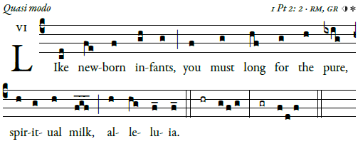

Sing joyfully to God our strength,
shout in triumph to the God of Jacob.
Raise a song and sound the timbrel,
the sweet-sounding harp and the lute;

blow the trumpet at the new moon,
when the moon is full, on our feast.
For this is a statute in Israel,
a command of the God of Jacob.

“I freed your shoulder from the burden;
You called in distress and I delivered you.

