Easter 5 C Responsorial Psalm

[**Ps 145:8-9, 10-11, 12-13**](http://www.usccb.org/bible/readings/bible/psalms/145:8)

**OCP**

C Bb C F Gm C

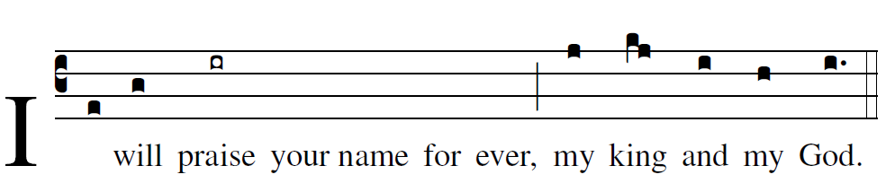

or

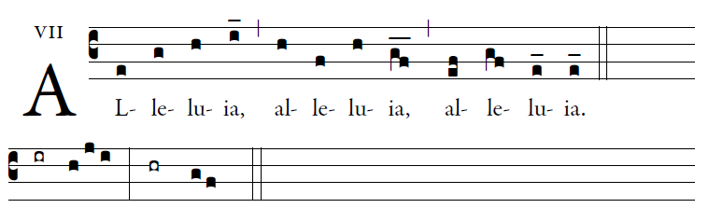  
The LORD is gra- |cious and merciful,  
slow to anger and | of great kindness.  
The LORD is| good to all  
and compassionate toward | all his works.

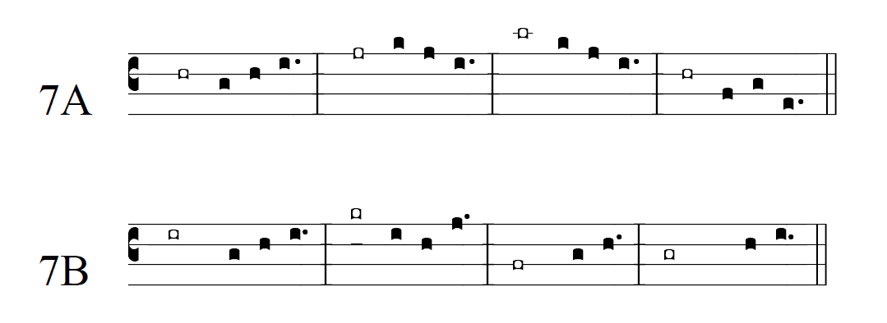  
Let all your works give you | thanks, O LORD,  
and let your faithful | ones bless you.  
Let them discourse of the glory | of your kingdom  
and speak | of your might.

Let them make known your might to the child- |ren of Adam,  
and the glorious splendor | of your kingdom.  
Your kingdom is a kingdom| for all ages,  
and your dominion endures through all | generations.

