I will fulfill my vows before those who fear the LORD.
The lowly shall eat their fill;
they who seek the LORD shall praise him:
“May your hearts live forever!”
All the ends of the earth
shall remember and turn to the LORD;
all the families of the nations
shall bow down before him.
To him alone shall bow down
all who sleep in the earth;
before him shall bend
all who go down into the dust.
And to him my soul shall live;
my descendants shall serve him.
Let the coming generation be told of the LORD
that they may proclaim to a people yet to be born
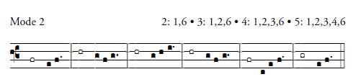
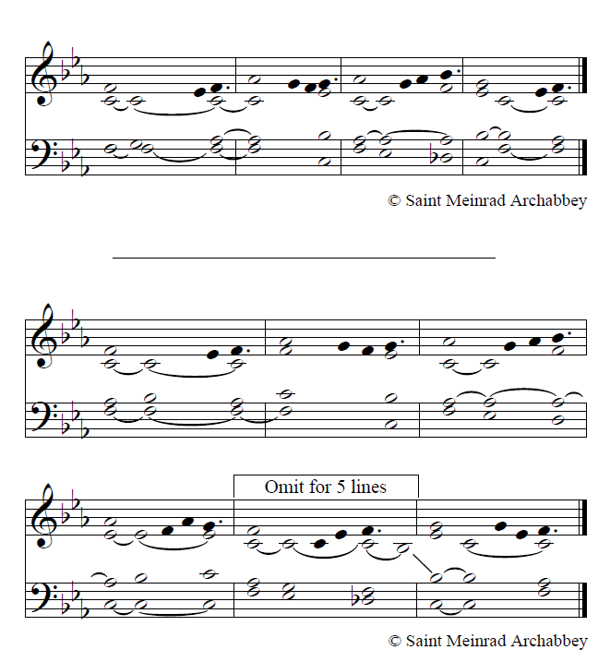
R. Alleluia, alleluia.
Remain in me as I remain in you, says the Lord.
Whoever remains in me will bear much fruit.
R. Alleluia, alleluia.

