Lamb of God

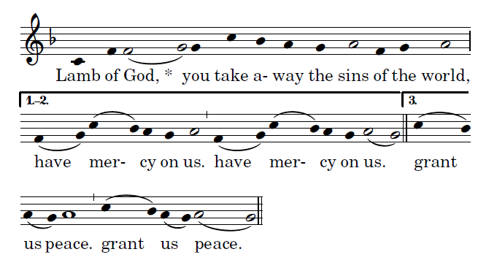

Communion Antiphon yeaRSab &C

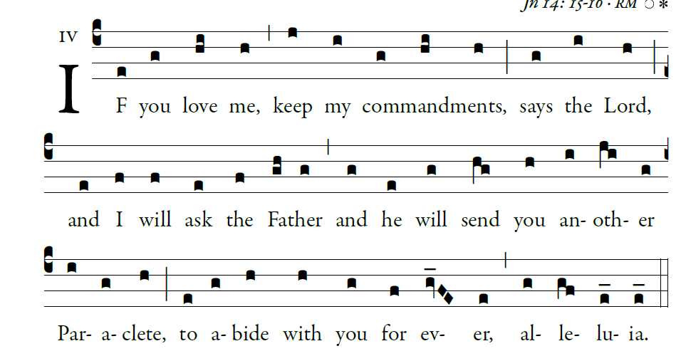
Illuminarepublications.com

Recessional Hymn:

“On This Day, O Beautiful Mother ” #707 MI

Sixth Sunday of Easter

Entrance Antiphon

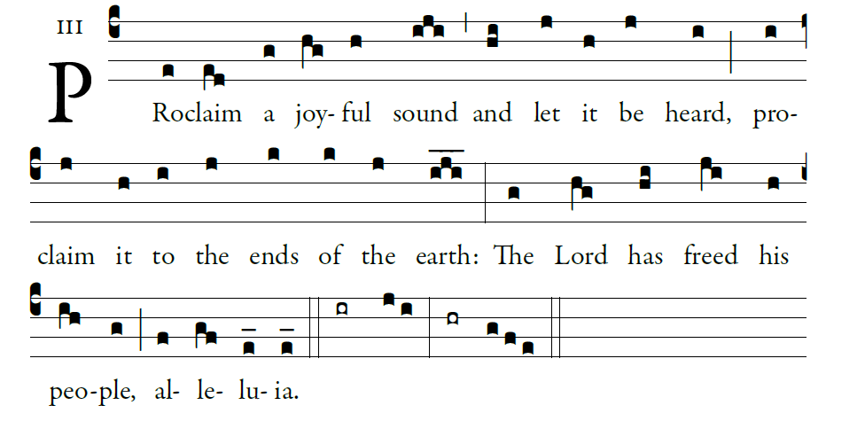
Illuminarepublications.com
Gloria
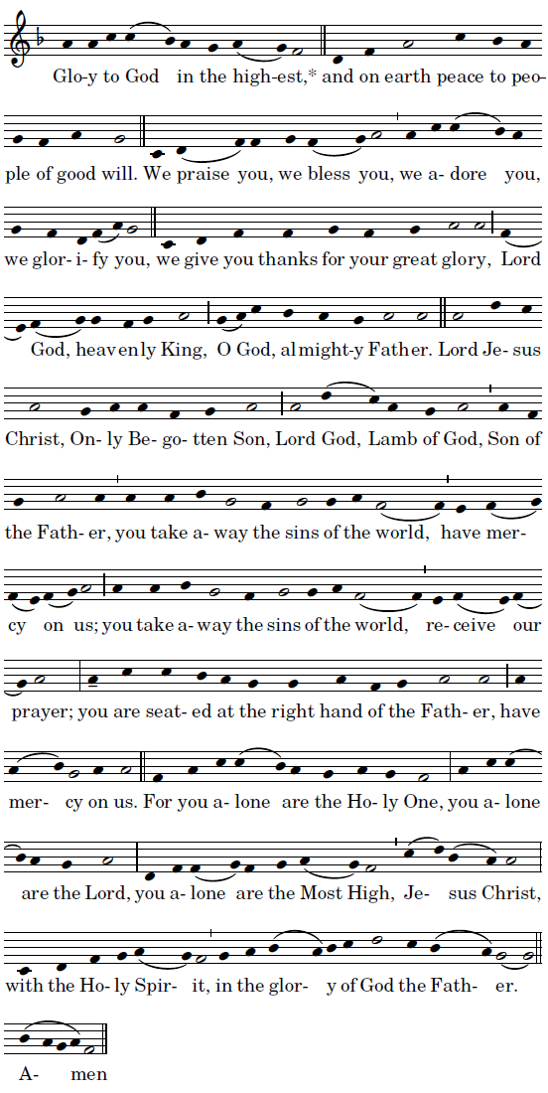

Mass ordinaries ©Richard Clark reprinted with permission

Responsorial Psalm
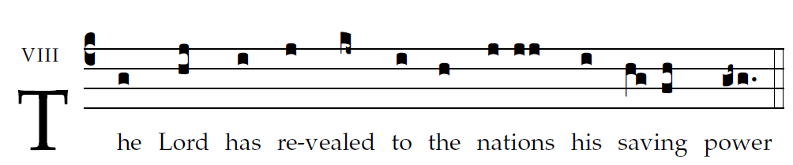

Sing to the LORD a new song,
for he has done wondrous deeds;
His right hand has won victory for him,
his holy arm.
The LORD has made his salvation known:
in the sight of the nations he has revealed his justice.
He has remembered his kindness and his faithfulness
toward the house of Israel.

All the ends of the earth have seen
the salvation by our God.
Sing joyfully to the LORD, all you lands;
break into song; sing praise

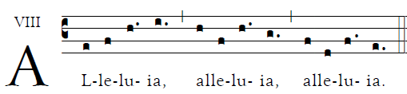

Offertroy Hymn # 94 TM “Veni Sancte Spiritus”

Holy
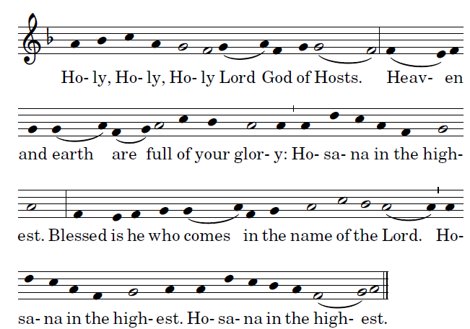

Acclamation
