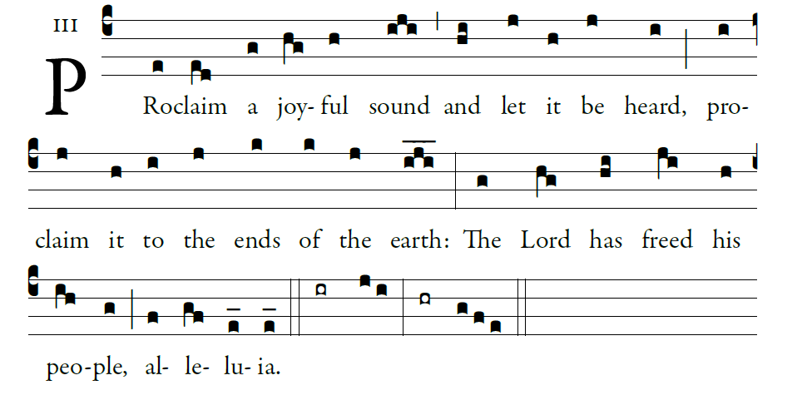
Illluminarepublications.com

1. Proclaim it to the ends of the earth,
alleluia, alleluia.
2. Cry out with joy to God, all the earth;
O sing to the glory of his name.

3. O render him glorious praise.
Say to God, “How awesome your deeds!
4. Because of the greatness of your strength,
your enemies fawn upon you.

5. Before you all the earth shall bow down,
shall sing to you, sing to your name!”
6. Come and see the works of God:
awesome his deeds among the children of men.

7. Glory be to the Father, and to the Son,
and to the Holy Spirit.
As it was in the beginning, is now, and ever shall be,
world without end. Amen.

