ENTRANCE ANTIPHON

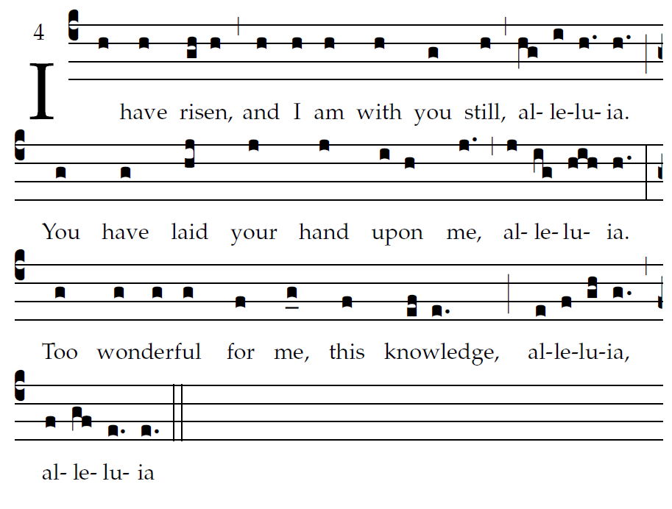
Simple English Propers CMAA : adapted to the text of the Roman Missal

O Lord, you search me and you know me.
You yourself know my resting and my rising;
you discern my thoughts from afar.

You mark when I walk or lie down;
you know all my ways through and through.
Before ever a word is on my tongue,
you know it, O Lord, through and through.

O where can I go from your spirit,
or where can I flee from your face?
⁸If I climb the heavens, you are there.
If I lie in the grave, you are there.

RESPONSORIAL PSALM
Paul Ford
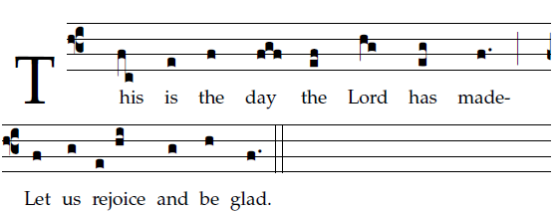

Give thanks to the LORD, for he is good, for his mercy endures forever.
Let the house of Israel say,
“His mercy endures forever.”
“The right hand of the LORD has struck with power;
the right hand of the LORD is exalted.
I shall not die, but live,
and declare the works of the LORD.”
The stone which the builders rejected
has become the cornerstone.
By the LORD has this been done;
it is wonderful in our eyes.
SEQUENCE AND ALLELUIA
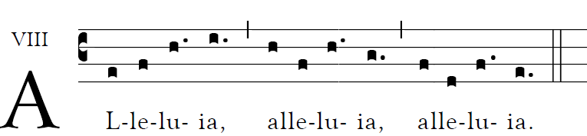

OFFERTORY HYMN : “Christ , the Lord is Risen Again”

COMMUNION ANTIPHON

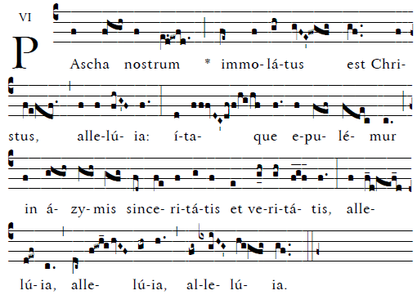

Christ Our Passover has been sacrificed,Therefore let us keep the feast with the unleavened bread of sincerity and truth Alleluia.

I called to the LORD in my distress;
he has answered and freed me.
The LORD is at my side; I do not fear.
What can mankind do against me?

The LORD is at my side as my helper;
I shall look in triumph on my foes.
It is better to take refuge in the LORD
than to trust in man;
it is better to take refuge in the LORD
than to trust in princes.

RECESSIONAL HYMN: “Jesus Christ is Risen Today”

EASTER SUNDAY

