COMMUNION HYMN

1. Jesus, sought by the maddened rabble,
like meekest of lambs driven to the slaughter

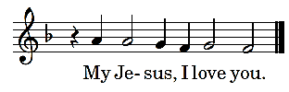

Jesus, for thirty silver pieces
ungratefully sold by Judas the traitor. 

Jesus, down cast with sorrow and pain,
longing anxiously: death for man's salvation.  
 
Jesus, in the dark olive garden
shedding bloody sweat, accepting the chalice 

Jesus, snared slyly into cruel hands
by Judas the traitor, ungrateful disciple. 

Jesus, roughly bound by drugged hire-lings:
the rope, coarse and strong tearing your flesh sorely. 

Jesus, jeered and scoffed by the rabble.
before the mock court of the highpriest Annas.   
                           
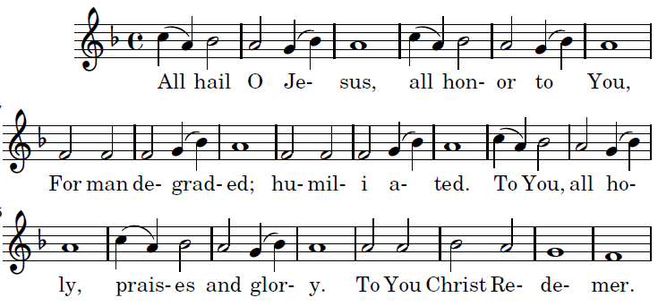

FRIDAY OF THE LORD’S PASSION

ADORATION OF THE CROSS Ralph Bednar z2016

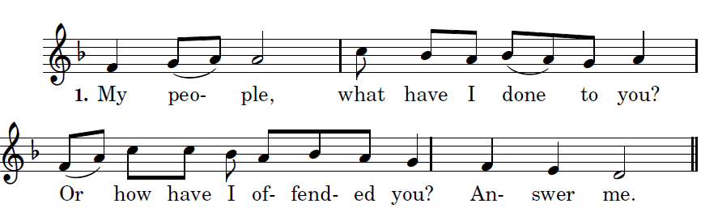

Because I led you out of the land of Egypt,
you have prepared a Cross for your Savior

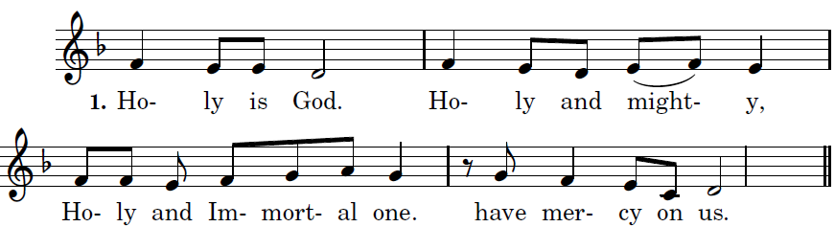

Because I led you out through the desert for forty years
and fed you with manna
and brought you into a land of plenty,
you have prepared a cross for your Savior.

Holy is God

What more should I have done for you
and have not done?
Indeed, I planted you as my most beautiful chosen vine
and you have turned very bitter for me,
for in my thirst you gave me vinegar to drink
and with a lance you pierced your Savior’s side.

Holy is God

I scourged Egypt for your sake with its firstborn sons,
and you scourged me and handed me over.
I led you out from Egypt/ as Pharoah
lay sunk in the Red Sea,
and you handed me over to the chief priests

My people. . .

I opened up the sea before you,
and you opened my side with a lance.
I went before you in a pillar of cloud,
and you led me into Pilate’s palace.

My people. . .

I fed you with manna in the desert,
and on me you rained blows and lashes.
I gave you saving water from the rock to drink,
and for drink you gave me gall and vinegar.

My people . . .

I struck down for you the kings of the Canaanites,
and you struck my head with a reed.
I put in your hand a royal scepter,
and you put on my head a crown of thorns.

My people . . .
I exalted you with great power,
and you hung me on the scaffold of the Cross

My people . . .
Holy s God . . .

PREPARATION OF THE ALTAR for COMMUNION
As the Eucharist os brought into the church

Hail, true body born of the Virgin Mary, Who truly suffered, sacrificed on the Cross for man, Whose pierced side overflowed with water and blood , Be for us a foretaste in the test of death. O sweet Jesus! O Loving Jesus! O Jesus Son of Mary.



  

