 Save your people, Lord, and bless your inheritance.
 Govern and uphold them now and always.
 Day by day we bless you.
 We praise your name for ever.
 Keep us today, Lord, from all sin.
 Have mercy on us, Lord, have mercy.
 Lord, show us your love and mercy,
 for we have put our trust in you.
 In you, Lord, is our hope:
 And we shall never hope in vain.

A plenary indulgence is granted to the Christian faithful who, in a church or in an oratory, are present [take part] in a recitation or solemn chant of: ... 2° the Te Deum hymn, on the last day of the year, in thanksgiving to God for the favors received in the course of the entire year.

RECESSIONAL HYMN: “Angels We Have Heard on High” #9

THE HOLY FAMILY OF JESUS MARY AND JOSEPH
DECEMBER 31

ENTRANCE HYMN : “O Come, All Ye Faithful” #64

ORDINARY OF THE MASS: Mass of St Paul the Apostle

RESPONSORIAL PSALM
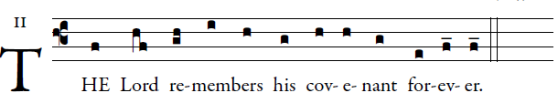
©illuminarepublications

Give thanks to the LORD, invoke his name;
make known among the nations his deeds.
Sing to him, sing his praise,
proclaim all his wondrous deeds.
Glory in his holy name;
rejoice, O hearts that seek the LORD!
Look to the LORD in his strength;
constantly seek his face.
You descendants of Abraham, his servants,
sons of Jacob, his chosen ones!
He, the LORD, is our God;
throughout the earth his judgments prevail.
He remembers forever his covenant
which he made binding for a thousand generations
which he entered into with Abraham
and by his oath to Isaac.

OFFERTORY HYMN: “ O Little Town of Bethlehem” #81

COMMUNION HYMN:
“ Let All Mortal Flesh Keep Silence” #135

THANKSGIVING HYMN After Communion

TE DEUM
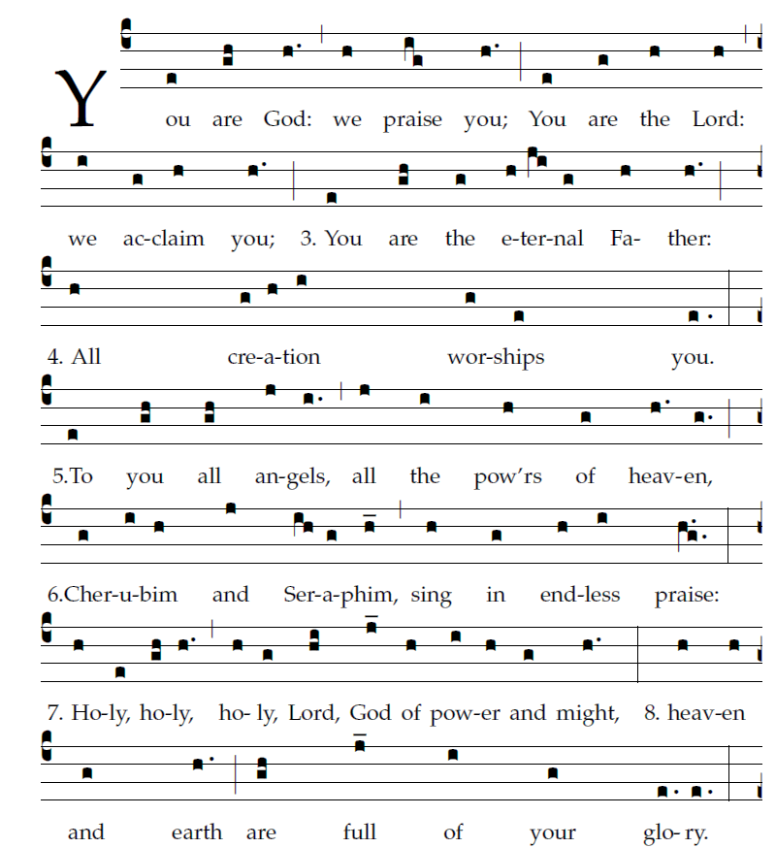

Music : R. Bednarz 2017
Text©1974, International Commission on English in the Liturgy Corporation. All rights reserved.

