



**FIRST SUNDAY OF LENT** YEAR C

ENTRANCE ANTIPHON

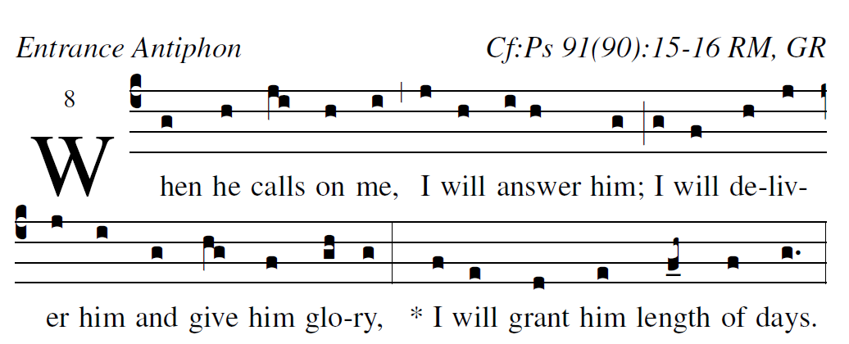

**Illuminare publication.com**  Adam Bartlet

***Psalm 91***

**He who dwells in the shelter of *the Most High,***

**and abides in the shade of the *Almighty,***

**says to the *LORD,* “*My refuge,***

**my stronghold, my God in whom *I trust!”***

**He will free you from the snare *of the fowler,***

**from the destruc*tive plague;***

**he will conceal you with *his pinions,***

**and under his wings you *will find refuge.***

**His faithfulness is buckler *and shield.***

**For you has he command*ed his angels***

**to keep you in all *your ways.***

**They shall bear you up*on their hands,***

**lest you strike your foot against *a stone.***

**On the lion and the viper *you will tread,***

**and trample the young lion and *the serpent.***

OFFERTORY HYMN: “Forty Days and Forty Nights”

COMMUNION ANTIPHON:

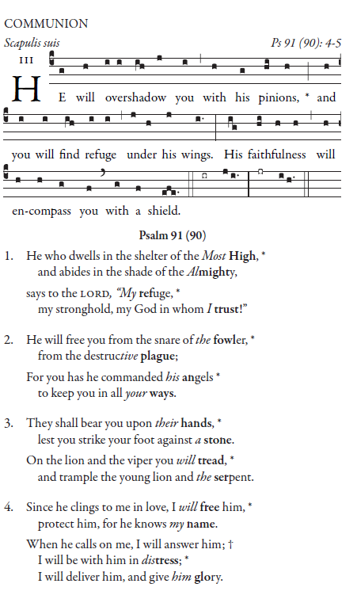

***ALL SING***

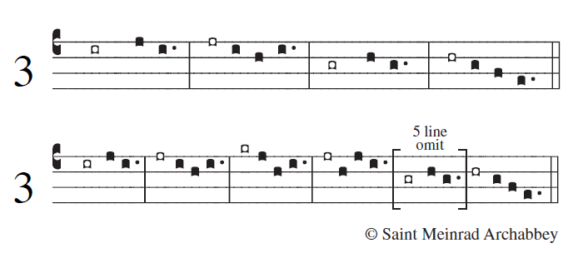

**He who dwells in the shelter of the  *Most High,***

**and abides in the shade of *the Almighty*,**

**says to the LORD, “ *My refuge,***

**my stronghold, my God in *whom I trust!”***

**He will free you from the snare of *the fowler,***

**from the de-s*tructive plague;***

**he will conceal you with *his pinions,***

**and under his wings you *will find refuge.***

**They shall bear you upon *their hands,***

**lest you strike your foot a- *gainst a stone.***

**On the lion and the viper you *will tread*,**

**and trample the young lion *and the serpent.***



**© SAINT MEINRAD ARCHABBEY**

**Since he clings to me in love, I will *free him*, [5]**

**protect him, for he *knows my name.***

**When he calls on me*, I will* *answer him;***

**I will be with him *in distress*;**

**I will deliver him, and *give him glory.***

** **

**© SAINT MEINRAD ARCHABBEY**

**1With length of days I *will content him;***

**I will show him my *saving power***

**RECESSIONAL HYMN**

***“ Hosea” “Come back to me”***