COMMUNION ANTIPHON:
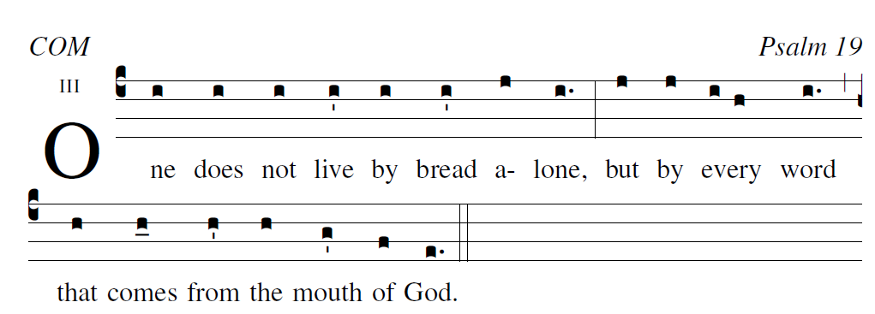
Psalm 19

The law of the LORD is perfect;
it revives the soul.
The decrees of the LORD are steadfast;
they give wisdom to the simple.

The precepts of the LORD are right;
they gladden the heart.
The command of the LORD is clear;
it gives light to the eyes.

The fear of the LORD is pure,
abid-ing forever.
The judgments of the LORD are true;
they are, all of them, just.

They are more to be desired than gold,
than quantities of gold.
And sweeter are they than honey,
than honey flowing from the comb.

RECESSIONAL HYMN:
“Forty Days and Forty Nights”

FIRST SUNDAY OF LENT

ENTRANCE ANTIPHON
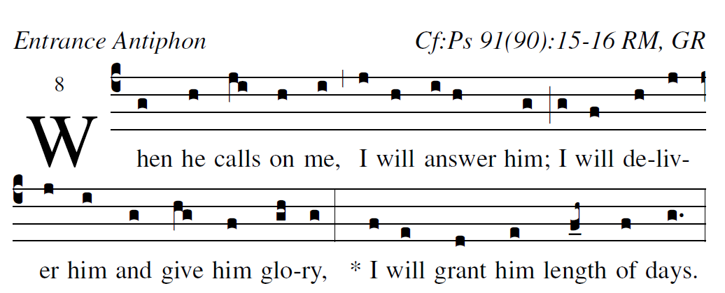
Illuminare publication.com Adam Bartlet

Psalm 91
He who dwells in the shelter of the Most High,
and abides in the shade of the Almighty,
says to the LORD, “My refuge,
my stronghold, my God in whom I trust!”

He will free you from the snare of the fowler,
from the destructive plague;
he will conceal you with his pinions,
and under his wings you will find refuge.
His faithfulness is buckler and shield.

For you has he commanded his angels
to keep you in all your ways.
They shall bear you upon their hands,
lest you strike your foot against a stone.
On the lion and the viper you will tread,
and trample the young lion and the serpent.

OFFERTORY HYMN:

“Attende Domine Todays Missal

SANCTUS Music copyright © 2014 Richard J. Clark | rjcceciliamusic.com
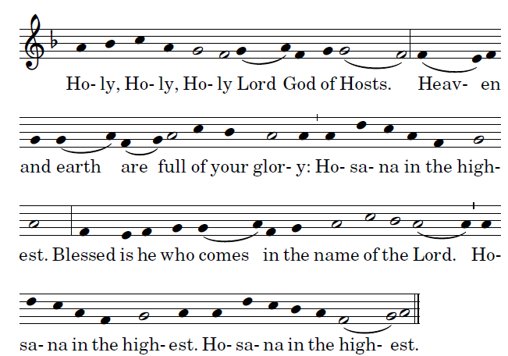

MEMORIAL ACCLAMATION
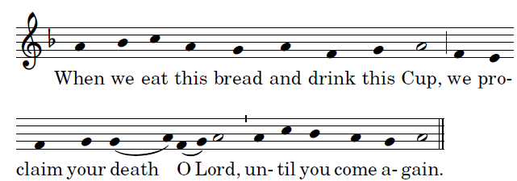

LAMB OF GOD
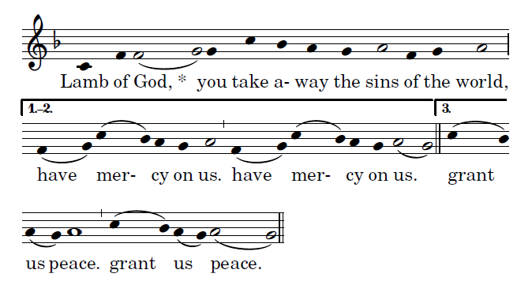

2015, 2016

