COMMUNION ANTIPHON:
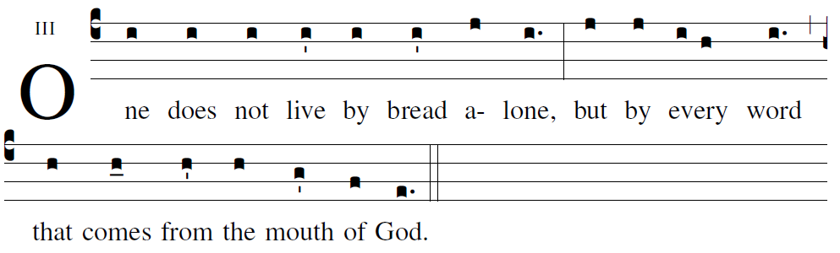
Psalm 19

The law of the LORD is perfect;
it revives the soul.
The decrees of the LORD are steadfast;
they give wisdom to the simple.

The precepts of the LORD are right;
they gladden the heart.
The command of the LORD is clear;
it gives light to the eyes.

COMMUNION HYM “ O Saving Vicitim”

RECESSIONAL HYMN:

“Forty Days and Forty Nights”

FIRST SUNDAY OF LENT

ENTRANCE ANTIPHON
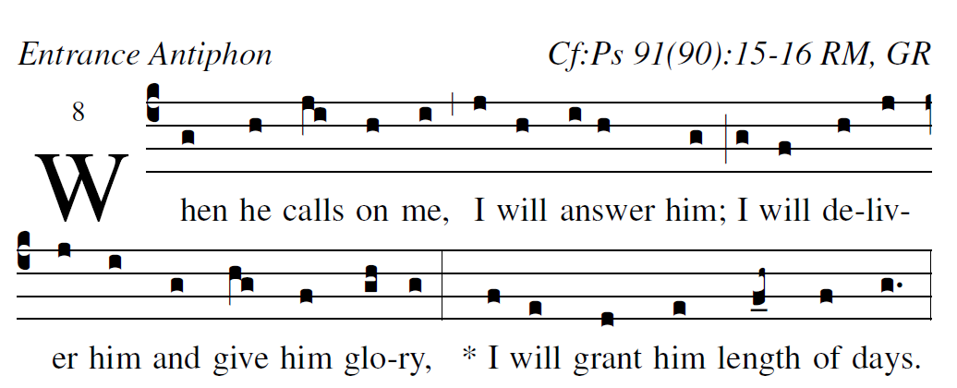
Illuminare publication.com Adam Bartlet

Psalm 91
He who dwells in the shelter of the Most High,
and abides in the shade of the Almighty,
says to the LORD, “My refuge,
my stronghold, my God in whom I trust!”

He will free you from the snare of the fowler,
from the destructive plague;
he will conceal you with his pinions,
and under his wings you will find refuge.
His faithfulness is buckler and shield.

For you has he commanded his angels
to keep you in all your ways.
They shall bear you upon their hands,
lest you strike your foot against a stone.
On the lion and the viper you will tread,
and trample the young lion and the serpent.

KYRIE #902 MI (optional)

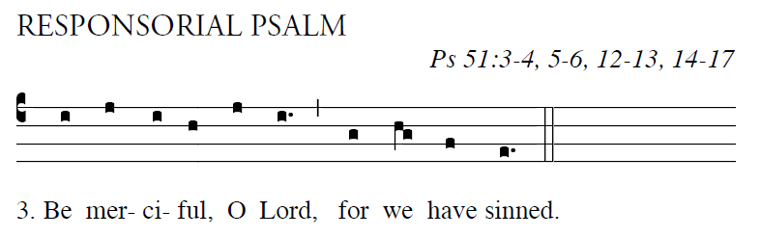

Have mercy on me, O God, in your goodness;
in the greatness of your compassion wipe out my of-fense.
Thoroughly wash me from my guilt
and of my sin cleanse me.

  Be merciful, O Lord, for we have sinned.

For I acknowledge my of-fense,
and my sin is be-fore me always:
“Against you only have I sinned,
and done what is evil in your sight.”

. Be merciful, O Lord, for we have sinned.

A clean heart create for me, O God,
and a steadfast spirit re-new with-in me.
Cast me not out from your presence,
and your Holy Spirit take not from me.

. Be merciful, O Lord, for we have sinned.

Give me back the joy of your sal-vation,
and a willing spirit sus- tain in me.
O Lord, open my lips,
and my mouth shall proclaim your praise.

. Be merciful, O Lord, for we have sinned

OFFERTORY HYMN:

“Soul of My Savior” Anima Christe

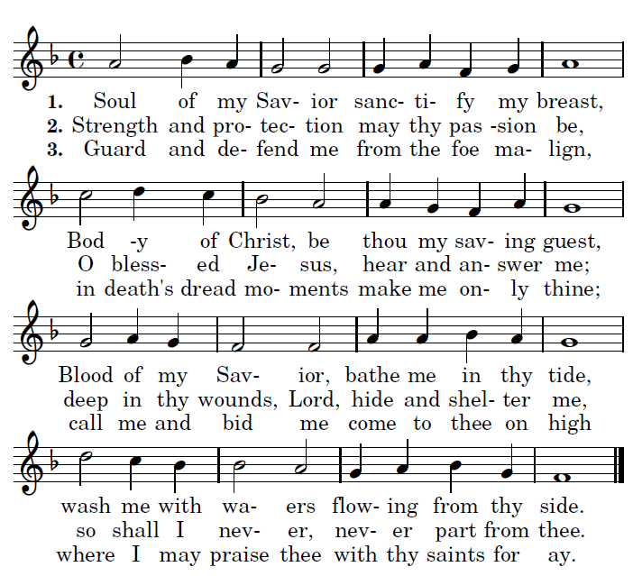

Mass of St. Francis Cabrini : #906 - #911 MI
Holy, Acclamation, Amen, Lamb

2017 A

