IMPOSITION OF ASHES
Immutemur RB 2013
Antiphon

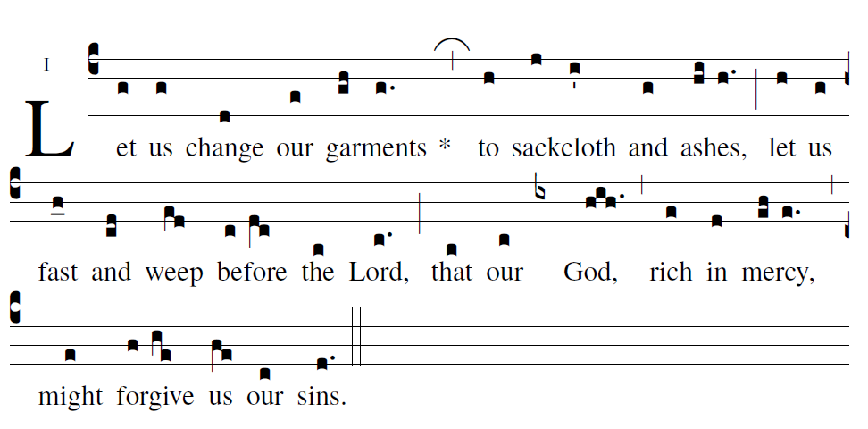

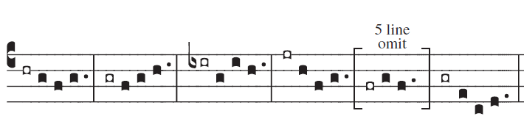

Psalm 90

O Lord, you have been our refuge, [5]
from generation to generation.
^{Bb} Before the mountains were born,
^{C} or the earth or the world were brought forth,
you are God, from age to age.

You turn man back to dust, [5]
and say, “Return, O children of men.”
^{Bb} To your eyes a thousand years
^{C} are like yesterday, come and gone,
or like a watch in the night.

You sweep them away like a dream,
like grass which is fresh in the morning.
In the morning it sprouts and is fresh;
by evening it withers and fades.

Indeed, we are consumed by your anger;
we are struck with terror at your fury.
You have set our guilt before you,
our secrets in the light of your face.

All our days pass away in your anger.
Our years are consumed like a sigh.
Seventy years is the span of our days,
or eighty if we are strong.

And most of these are toil and pain.
They pass swiftly and we are gone.
Who understands the power of your anger?
Your fury matches the fear of you.

Then teach us to number our days,
that we may gain wisdom of heart.
Turn back, O LORD! How long?
Show pity to your servants.

At dawn, fill us with your merciful love;
we shall exult and rejoice all our days.
Give us joy for the days of our affliction,
for the years when we looked upon evil.

Let your deed be seen by your servants, [5]
and your glorious power by their children.
^{Bb} Let the favor of the Lord our God be upon us;
^{C} give success to the work of our hands.
O give success to the work of our hands.

Psalm 103
The LORD is compassion-ate and gracious,
slow to anger and rich in mercy.
He will not always find fault;
nor persist in his ang-er forever.

He does not treat us according to our sins, [6]
nor repay us according to our faults.
For as the heavens are high above the earth,
so strong his mercy for those who fear him.
As far as the east is from the west,
so far from us does he remove our transgressions.

As a father has compassion on his children,
the LORD’s compassion is on those who fear him.
For he knows of what we are made;
he remembers that we are dust.

Man, his days are like grass;
he flowers like the flower of the field.
The wind blows, and it is no more,
and its place never sees it a-gain.

But the mercy of the LORD is ever-lasting [5]
upon those who hold him in fear,
^{Bb} upon children’s children his justice,
^{C} for those who keep his covenant,
and remember to fulfill his commands.

Psalm 51

Do not cast me away from your presence;
take not your holy spirit from me.
Restore in me the joy of your salvation;
sustain in me a willing spirit.

My sacrifice to God, a broken spirit: [5]
a broken and humbled heart,
^{Bb} O God, you will not spurn.
^{C} In your good pleasure, show favor to Sion;
rebuild the walls of Jerusalem.

Hosea 6:6

I want a loving heart more than sacrifice,
Knowledge of my ways more than Holocausts.

The texts of The Revised Grail Psalms, as they appear online via the links on this page, are for reference only. Bona fide publishers of liturgical resources may purchase fully formatted Word files of the text. Contactgrail@giamusic.com for more details.
The Revised Grail Psalms Copyright © 2010, Conception Abbey/The Grail, admin. by GIA Publications, Inc., www.giamusic.com All rights reserved.
The Revised Grail Psalms were confirmed by decree of the Congregation for Divine Worship and the Discipline of the Sacraments on March 19, 2010 (Prot. N. 172/09/L).

user-notes: During imposition of ashes: ;
commentary: Joel Cf. Jl 2: 17, Est 4: 17 ;
annotation: An i ;
centering-scheme: english;
%spacing: vichi;
%font: times;
%width: 5;
%height: 11;
%%
(c4)Let(g) us(g) change(d) our(f) {gar}ments(gh / g.)* (,)to(h) {sack}cloth(j/ i') and(g) {ash}es,(hi/ h.) (;)
let(h) us(g) fast(h_0) and(ef) weep(gf) {be}fore(e/ fe) the(c) Lord,(d.) (;)
that(c) our(d) (ix) God,(hih.) (,) rich(g) in(f) {mer}cy,(gh/ g.) (,) might(e) {for}give(f /ge) us(fe) our(c) sins.(d.) (::)

2015 (c4)Let(g) us(g) change(d) our(f) {gar}ments(gh / g.)* (,)to(h) {sack}cloth(ij/ ih) and(g) {ash}es,(h/ h.) (;)
let(h) us(g) fast(h_0) and(ef) weep(gf) {be}fore(e/ fe) the(c) Lord,(d.) (:)
that(c) our(d) (ix) God,(hih.) (,) rich(g) in(f) {mer}cy,(gh/ g.) (;) might(e) {for}give(f /ge) us(fe) our(c) sins.(d.) (::)

