©illuminarepublications Adam Bartlett

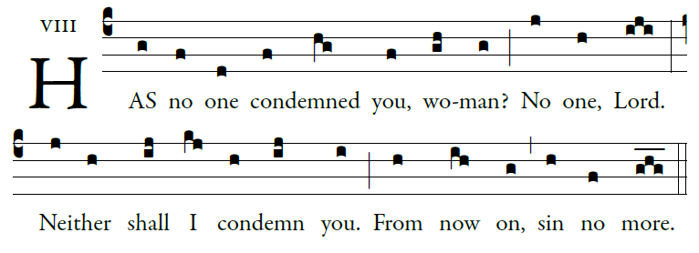

(Psalm 31[32]: 1-3, 5, 8, 10-11: GR, p. 124)

Blessed is he whose transgression is forgiven
whose sin is remitted.
²Blessed the man to whom the LORD imputes no guilt,
in whose spirit is no guile.

³I kept it secret and my frame was wasted.
I groaned all day long,

³To you I have acknowledged my sin;
my guilt I did not hide.
I said, “I will confess my transgression to the LORD.”
And you have forgiven the guilt of my sin.

I will instruct you and teach you
the way you should go;
I will fix my eyes upon you.

Many sorrows has the wicked,
but loving mercy surrounds
one who trusts in the LORD.

Rejoice in the LORD; exult, you just!
Ring out your joy, all you upright of heart!

Glory be to the Father, and to the Son
and to the Holy Spirit.
As it was in the beginning, is now, and ever shall be,
world without end. Amen

SIMPLE VERSION
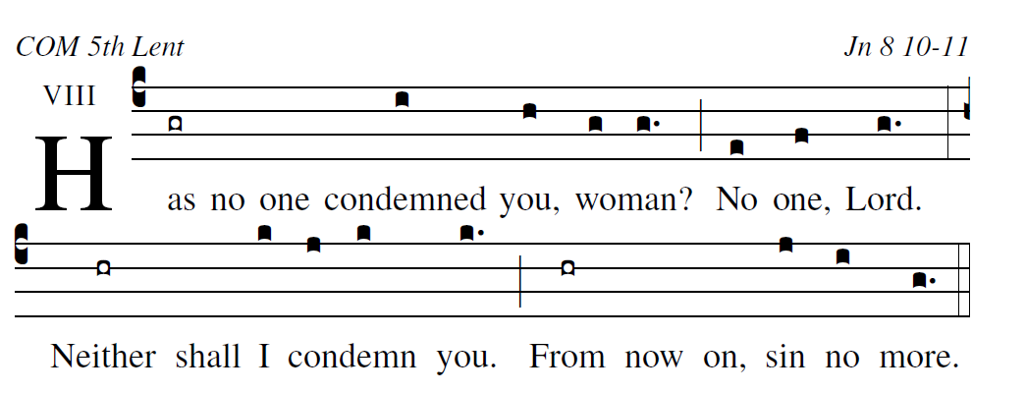
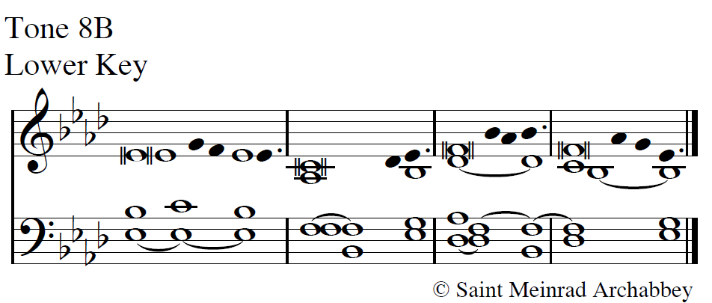
Blessed is he whose transgression is forgiven,
whose sin is remitted.
Blessed the man to whom the LORD imputes no guilt,
in whose spirit is no guile.
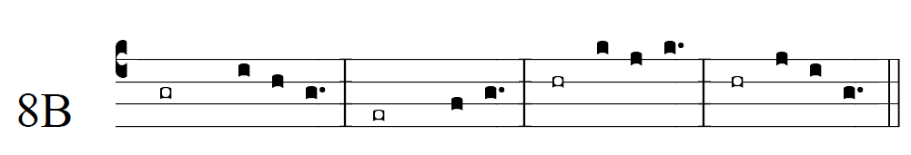

user-notes: COM 5th Lent ;
commentary: Jn 8 10-11 ;
annotation: viii ;
centering-scheme: english;
%spacing: vichi;
%font: times;
%width: 4.5;
%height: 11;
%%
(c4)Has(gr) no() one() {con}demned( / i) you,(h) {wo}man?(g/ g.) (;) No(e) one,(f) Lord.(g.) (:)
Neither(hr) shall() I(k) {con}demn(j / k) you.(k.) (;) From(hr) now() on,() sin(j) no(i) more.(g.) (::)

