But the just shall rejoice at the presence of God;
they shall exult with glad rejoicing.
O sing to God; make music to his name.

You poured down, O God, a generous rain;
when your people languished,
you restored their inheritance.
It was there that your flock began to dwell.

COMMUNION HYMN
“One Bread One Body” #340 Music Issue

RECESSIONAL HYMN
“Holy God, We Praise Thy Name”
Today’s Missal #97

PENTECOST

ENTRANCE ANTIPHON

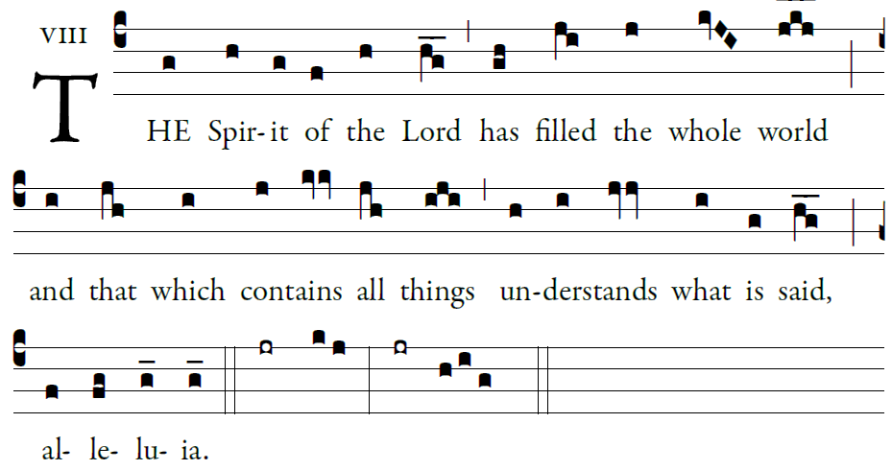
Illuminarepublications.com

Let God arise; let his foes be scattered.
Let those who hate him flee from his presence.
As smoke is driven away, so drive them away;
like wax that melts before the fire,
so the wicked shall perish at the presence of God.

But the just shall rejoice at the presence of God;
they shall exult with glad rejoicing.
O sing to God; make music to his name.
Extol the One who rides on the clouds.
The lord is his name; exult at his presence.

ORDINARY: Mass of St Francis Cabirnin
MUSIC ISSUE # 907-916

RESPONSORIAL PSALM
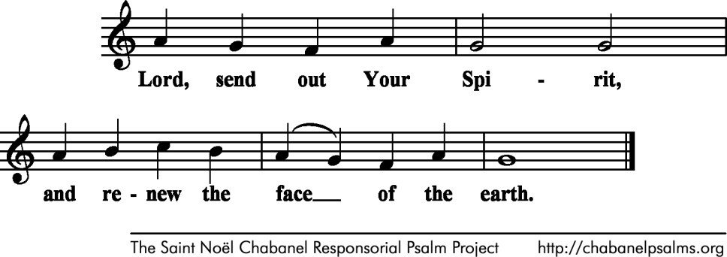
Chabanel Psalms

Bless the LORD, O my soul!
O LORD, my God, you are great indeed!
How manifold are your works, O LORD!
the earth is full of your creatures;

If you take away their breath, they perish
and return to their dust.
When you send forth your spirit, they are created,
and you renew the face of the earth.

May the glory of the LORD endure forever;
may the LORD be glad in his works!
Pleasing to him be my theme;
I will be glad in the LORD.

Sequence: “Come, O Holy Spirit, Come”
Today’s Missal
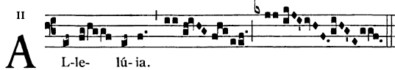
 

 Come Holy Spirit fill the hearts of you faithful
and kindle in them the fire of your love.

OFFERTROY HYMN “Veni Creator Spiritus”
#91 Today’s Missal

COMMUNION ANTIPHON

And suddenly there came a sound from heaven, as of a mighty wind coming, and it filled the whole house where they were sitting; and they were filled with the Holy Spirit and spoke of the marvels of God Alleluia.

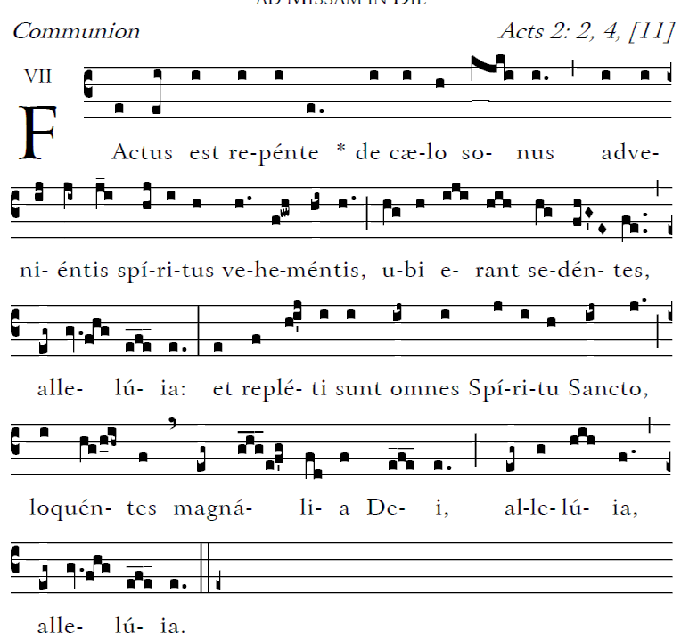

Let God arise; let his foes be scattered.
Let those who hate him flee from his presence.
As smoke is driven away, so drive them away;
like wax that melts before the fire,
so the wicked shall perish at the presence of God.

- continued

