^{Veni, Creator Spiritus}

COMMUNION ANTIPHON & HYMN
And suddenly there came a sound from heaven, as of a mighty wind coming, and it filled the whole house where they were sitting; and they were filled with the Holy Spirit and spoke of the marvels of God Alleluia.

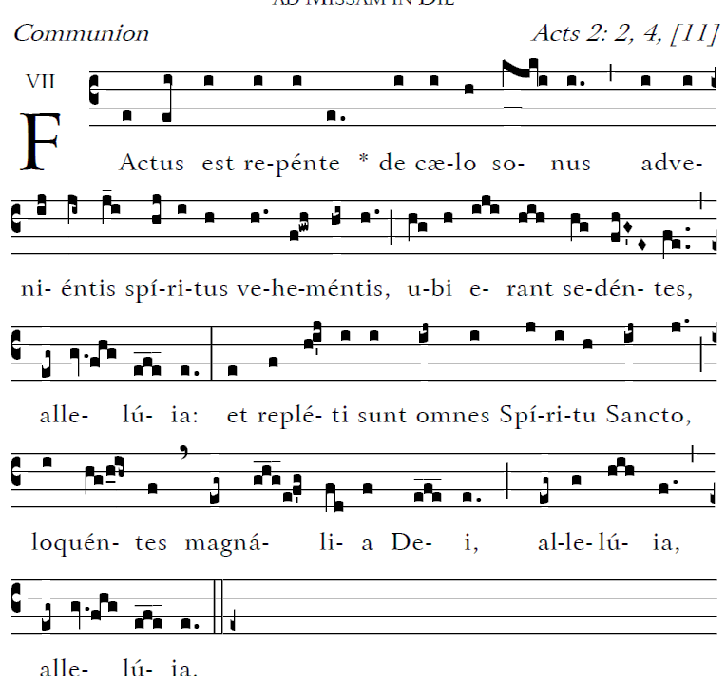

HYMN Veni Creator Spiritus 533 and 534

_______________________________________________
RECESSIONAL HYMN
“ Holy God, We Praise Thy Name” 775

PENTECOST

ENTRANCE ANTIPHON

Saint Meinrad Archabbey© 2012
Creative Commons Attribution-Noncommercial-No Derivative Works 3.0 United States License.

Let God arise; let his foes be scattered.
Let those who hate him flee from his presence.
As smoke is driven away, so drive them away;
like wax that melts before the fire,
so the wicked shall perish at the presence of God.

2023

RESPONSORIAL PSALM

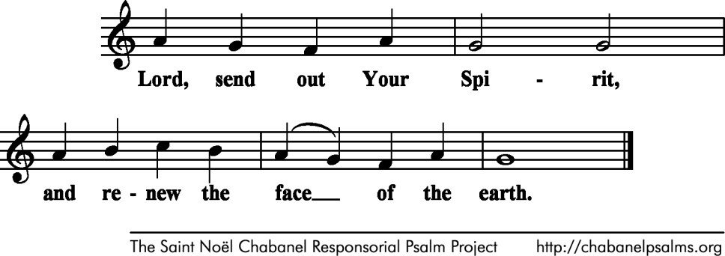
Chabanel Psalms

Bless the LORD, O my soul!
O LORD, my God, you are great indeed!
How manifold are your works, O LORD!
the earth is full of your creatures

If you take away their breath, they perish
and return to their dust.
When you send forth your spirit, they are created,
and you renew the face of the earth.

May the glory of the LORD endure forever;
may the LORD be glad in his works!
Pleasing to him be my theme;
I will be glad in the LORD.

SEQUENCE and ALLELUIA :

“Come, O Holy Spirit, Come” sung by cantor page 213

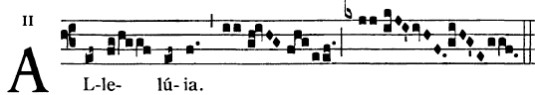

 Come Holy Spirit fill the hearts of you faithful
and kindle in them the fire of your love

OFFERTORY HYMN
“Come, Holy Ghost, Creator Blest,”646

