But the just shall rejoice at the presence of God;
they shall exult with glad rejoicing.
O sing to God; make music to his name.

Extol the One who rides on the clouds.
The LORD is his name; exult at his presence.
Father of orphans, defender of widows:
such is God in his holy place.

O God, when you went forth before your people,
when you marched out across the desert,
the earth trembled, heavens poured down rain:
at the face of God, the God of Sinai,
at the face of God, the God of Israel.

You poured down, O God, a generous rain;
when your people languished,
you restored their inheritance.
It was there that your flock began to dwell.

In your goodness, O God, you provided for the poor.
The LORD announces the command;
a mighty throng bears good tidings:
“The kings and armies are in headlong flight,
while you were at rest among the sheepfolds.”

RECESSIONAL HYMN: “Come Holy Ghost”

PENTECOST

ENTRANCE ANTIPHON

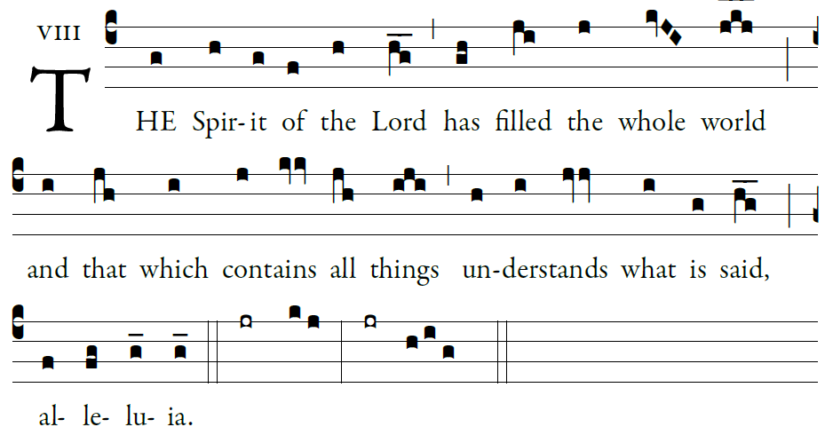
Illuminarepublications.com

Let God arise; let his foes be scattered.
Let those who hate him flee from his presence.
As smoke is driven away, so drive them away;
like wax that melts before the fire,
so the wicked shall perish at the presence of God.

But the just shall rejoice at the presence of God;
they shall exult with glad rejoicing.
O sing to God; make music to his name.
Extol the One who rides on the clouds.
The lord is his name; exult at his presence.

RESPONSORIAL PSALM
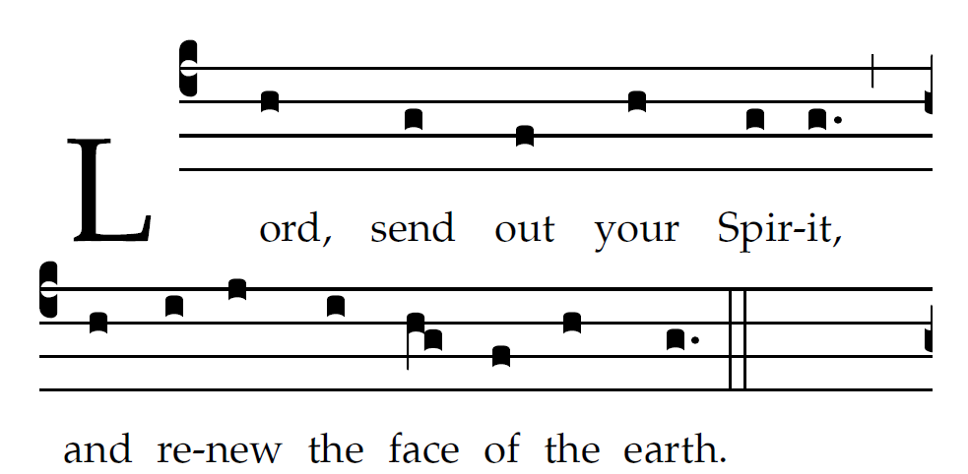
Chabanel Psalms

Bless the LORD, O my soul!
O LORD, my God, you are great indeed!
How manifold are your works, O LORD!
the earth is full of your creatures;

If you take away their breath, they perish
and return to their dust.
When you send forth your spirit, they are created,
and you renew the face of the earth.

May the glory of the LORD endure forever;
may the LORD be glad in his works!
Pleasing to him be my theme;
I will be glad in the LORD.

Sequence: “Come, O Holy Spirit, Come”
Today’s Missal
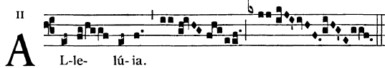
 

 Come Holy Spirit fill the hearts of you faithful
and kindle in them the fire of your love.

OFFERTROY HYMN “Veni Creator Spiritus”

COMMUNION ANTIPHON

And suddenly there came a sound from heaven, as of a mighty wind coming, and it filled the whole house where they were sitting; and they were filled with the Holy Spirit and spoke of the marvels of God Alleluia.

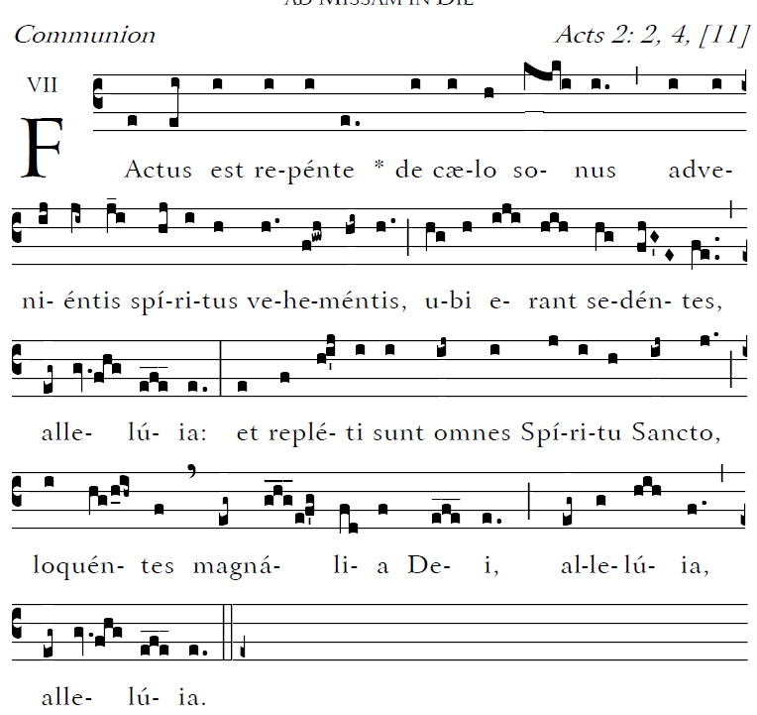

Let God arise; let his foes be scattered.
Let those who hate him flee from his presence.
As smoke is driven away, so drive them away;
like wax that melts before the fire,
so the wicked shall perish at the presence of God.

- continued

