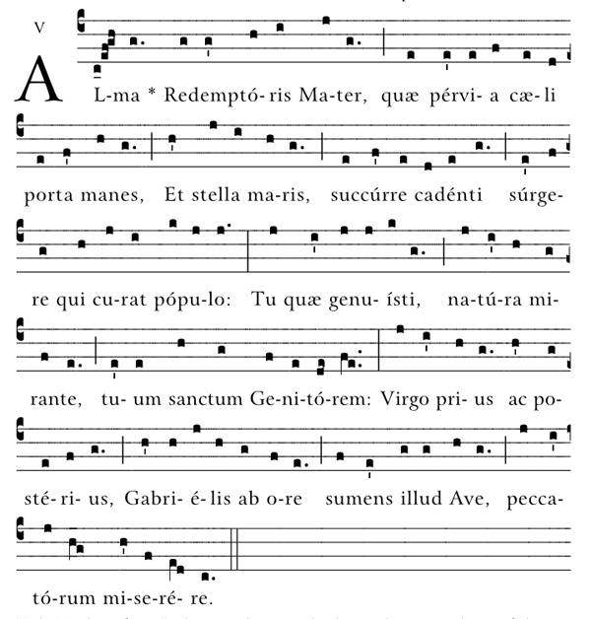
Holy mother of our Redeemer, thou gate leading to heaven and star of the sea; help the falling people who seek to rise, thou who, all nature wondering, didst give birth to thy holy Creator. Virgin always, hearing the greeting from Gabriel’s lips, take pity on sinners.

RECESSIONAL HYMN
Holy God We Praise Thy Name

proper antiphons from The Simple English Propers
Adam Bartlett ©CMAACreative commons , for free use

Presentation of the Lord

ENTRANCE ANTIPHON

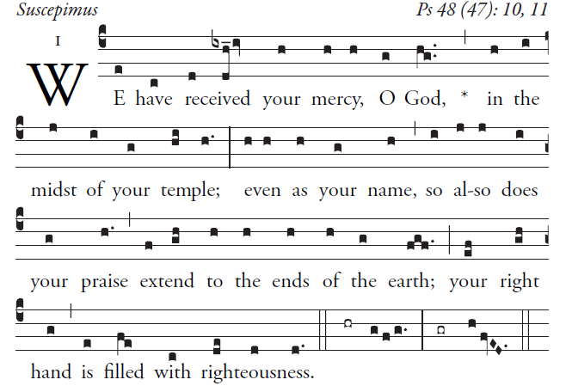

Great is the LORD and highly to be praised
in the city of our God.
His holy mountain rises in beauty,
the joy of all the earth.
Mount Sion, in the heart of the North,
the city of the Mighty King!
God, in the midst of its citadels,
has shown himself its stronghold.

OFFERTORY HYMN 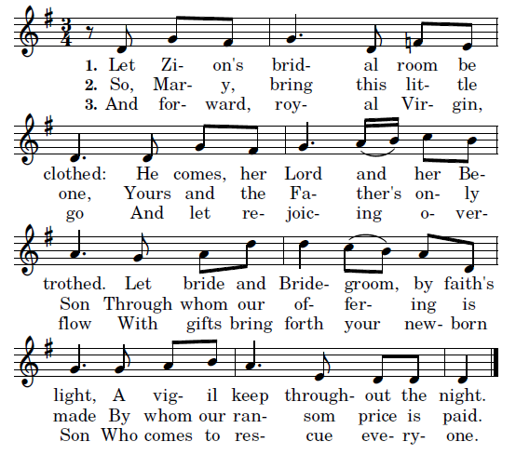
4. Saint Simeon, go forth in joy,
Exult to see the baby Boy:
Make known to all this Light divine
Who soon upon all lands shall shine
5. Lord Jesus Christ, the Glory bright
Who guides the nations into light
Be praised, and for eternity
Be glorified, O Trinity.

Text by Kathleen Pluth, 2009

COMMUNION ANTIPHON

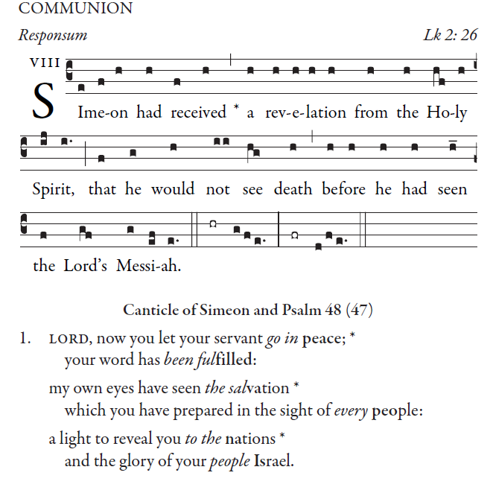

Alma Redemptoris Mater
Sung from the first Sunday of Advent until the Feast of the Purification on February 2 (the original ending date of the Christmas season), this prayer tells of Gabriel’s announcement, and of Mary’s divine motherhood
Continued next page ~

