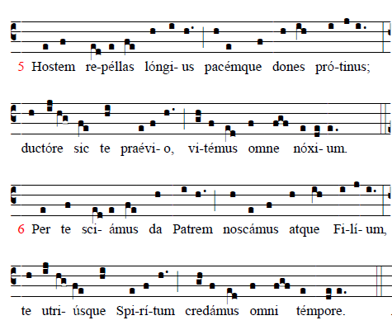

7. Deo Patri sit gloria, et Filio qui a mortuis
Surrexit, ac Paraclito, in saeculorum saecula. Amen.

5.Oh, may Thy grace on us bestow
the Father and the Son to know;
and Thee, through endless times confessed,
of both the eternal Spirit blest.
6. Drive far away our ghostly foe,
and thine abiding peace bestow;
if thou be our preventing Guide,
no evil can our steps betide

.

7.Praise we the Father and the Son and Holy Spirit with them One; and may the Son on us bestow the gifts that from the Spirit flow.

RECESSIONAL HYMN “Immaculate Mary”

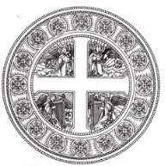
SOLEMNITY OF MARY
THE HOLY MOTHER OF GOD

ENTRANCE ANTIPHON Fr. Samuel Webber
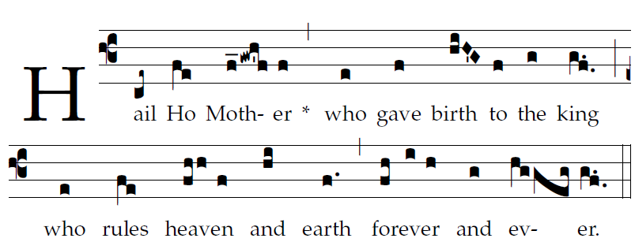
         Psalm 45
My heart overflows with a goodly theme:
As I sing to the king the song that I have made.

You are the fairest of the children of men
and graciousness is poured upon your lips:
Because God has blessed you for evermore.

So will the king desire your beauty :
He is your Lord, pay homage to him

The daughter of the king is clothed with splendor,
Her robes embroidered with pearls set in gold.

OFFERTORY “O Holy Mary”

COMMUNION HYMN “Silent Night”

COMMUNION HYMN “Veni Creator” §

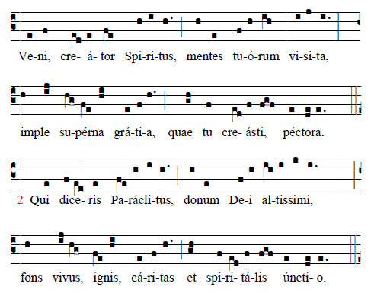

Come, Holy Ghost, Creator blest,
and in our hearts take up Thy rest;
come with Thy grace and heavenly aid,
To fill the hearts which Thou hast made.
O Comforter, to Thee we cry,
Thou heavenly gift of God most high,
Thou Fount of life, and Fire of love,
and sweet anointing from above.
§1. A plenary indulgence is granted to the Christian faithful who, in a church or in an oratory, are present [take part] in a recitation or solemn chant of: 1° the hymn Veni, Creator ... on the first day of the year, imploring divine assistance for the whole of the coming year... (Reference: Enchiridion Indulgentiarum, 4th edition, al. concessiones.)

+ + + + + + +

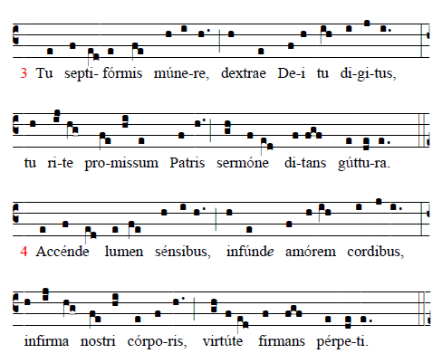

O Finger of the hand divine,
the sevenfold gifts of grace are thine;
true promise of the Father thou,
who dost the tongue with power endow.

Thy light to every sense impart,
and shed thy love in every heart;
thine own unfailing might supply
to strengthen our infirmity.
Continued

