COMMUNION: Solemnity of Mary

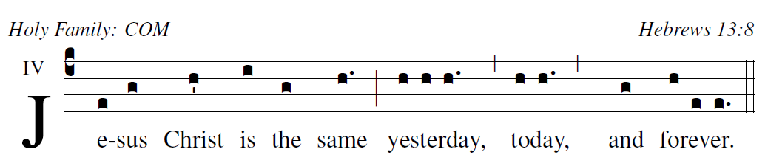

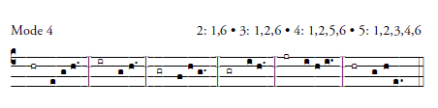

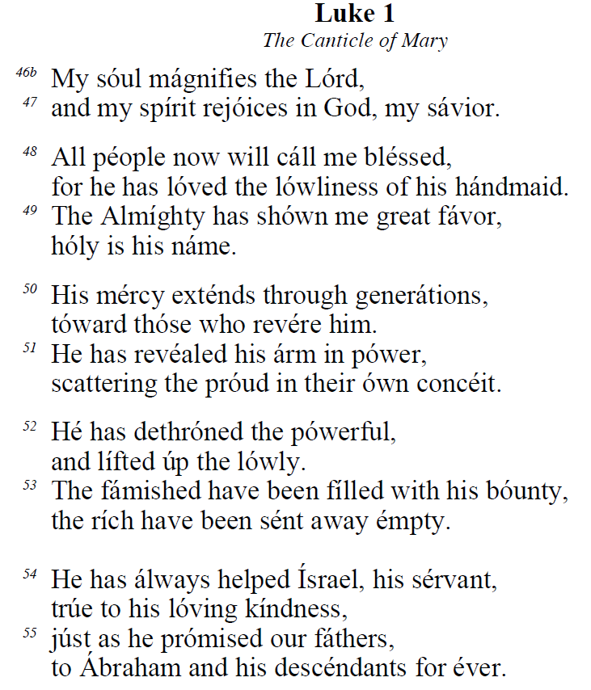

Alternate refrain

