RECESSIONAL HYMN

“Brightness of the Father’s Glory”
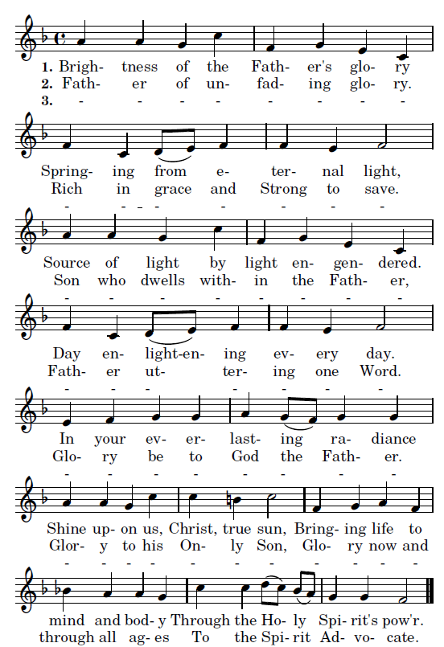

THE TRANSFIGURATION OF THE LORD

ENTRANCE ANTIPHON

RB 2017

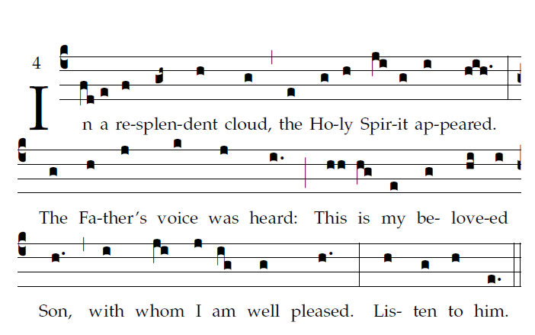
Psalm 84
How lovely is your dwelling place,
O LORD of hosts.
My soul is longing and yearning
for the courts of the LORD.
My heart and my flesh cry out
to the living God.

For the LORD God is a sun, a shield;
the LORD will give us his favor and glory.
He will not withhold any good
to those who walk without blame.
O LORD of hosts, how blessed
is the man who trusts in you!

Kyrie Gloria, Sanctus etc . Mass of St. Francis Cabrini 903…

RESPONSORIAL PSALM from Todays Missal

OFFERTORY HYMN

“ Oh, Wondrous Type ! Oh Vision Fair.”

MELODY: JESU DULCIS MEMORIA

O
h, wondrous type! Oh, vision fair
Of glory that the church may share,
Which Christ upon the mountain shows,
Where brighter than the sun he glows!
With Moses and Elijah nigh
The ‘n-carnate Lord holds converse high;
And from the cloud the Holy One
Bears record to the only Son.
With shining face and bright array
Christ wills to manifest today
What glory shall be theirs above
Who joy in God with perfect love.
And faithful hearts are raised on high
By this great vision’s mystery,
For which in joyful strains we raise
The voice of prayer, the hymn of praise.
O Father, with the eternal Son
And Holy Spirit ever one,
We pray you, bring us by your grace
To see your glory face to face.

COMMUNION ANTIPHONS

CONGREGATIONS REFRAIN
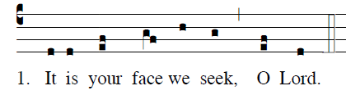

SCHOLA’S REFRAIN Fr. Columba Kelly, ©St. Meinrad Archabbey
PSALM 97

