these we will not hide from their children
but will tell them to the next generation.

Yet he commanded the clouds above,
and opened the gates of heaven.
He rained down manna to eat,
and gave them bread from heaven.

YOU ARE GOD (Te Deum)
You are God: we praise you;
You are the Lord: we acclaim you;
You are the eternal Father:
All creation worships you.
To you all the angels, all the powers of heaven,
Cherubim and Seraphim, sing in endless praise:
Holy, holy, holy Lord, God of power and might,
heaven and earth are full of your glory.
The glorious company of apostles praise you.
The noble fellowship of prophets praise you.
The white-robed army of martyrs praise you.
Throughout the world the holy Church acclaims you:
Father, of majesty unbounded,
your true and only Son, worthy of all worship,
and the Holy Spirit, advocate and guide.
You, Christ, are the king of glory,
the eternal Son of the Father
RECESSIONAL HYMN
“ Eternal Father Strong to Save”
The Solemnity of the Most Holy Trinity year B

ENTRANCE ANTIPHON Tob 12:6

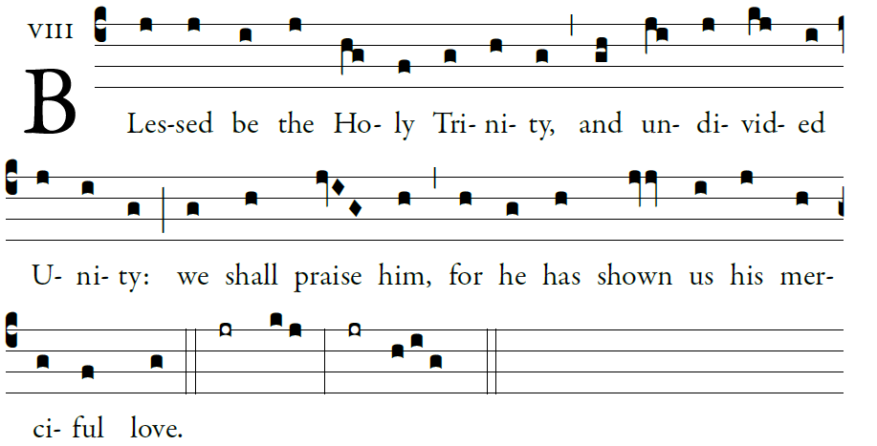
Illuminarepublications.com

O LORD, our Lord, how majestic
is your name through all the earth!
Your majesty is set above the heavens.

From the mouths of children and of babes
you fashioned praise to foil your enemy,
to silence the foe and the rebel. 

When I see the heavens, the work of your fingers,
the moon and the stars which you arranged,
⁵what is man that you should keep him in mind,
the son of man that you care for him?
Glory be…

KYRIE , GLORIA MISSA SIMPLEX

RESPONSORIAL PSALM Psalm 33

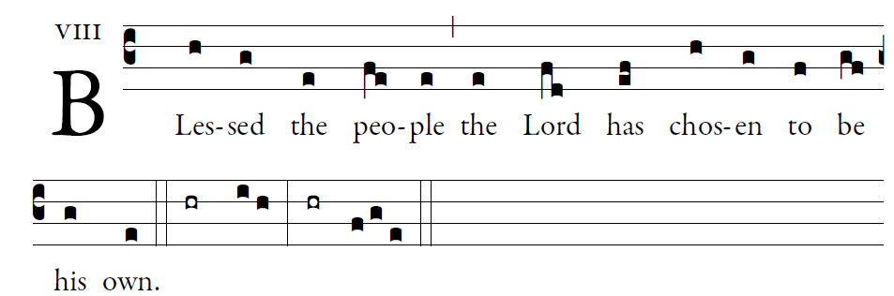
Illuminarepublications.com

Upright is the word of the LORD,
and all his works are trustworthy.
He loves justice and right;
of the kindness of the Lord the earth is full. 
By the word of the LORD the heavens were made;
by the breath of his mouth all their host.
For he spoke, and it was made;
he commanded, and it stood forth. 
See, the eyes of the LORD are upon those who fear him,
upon those who hope for his kindness,
To deliver them from death
and preserve them in spite of famine.  
Our soul waits for the LORD,
who is our help and our shield.
May your kindness, O LORD, be upon us
who have put our hope in you. 

ALLELUIA

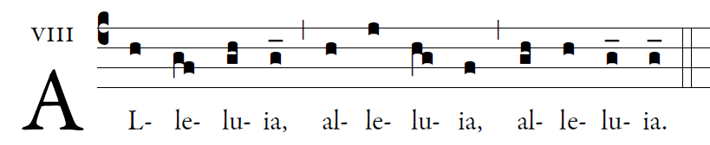
Illuminarepublications.com

Glory to the Father, the Son, and the Holy Spirit;
to God who is, who was, and who is to come.

OFFERTORY HYMN “O God Almighty Father”

HOLY, LAMB OF GOD MISSA SIMPLEX

COMMUNION ANTIPHON
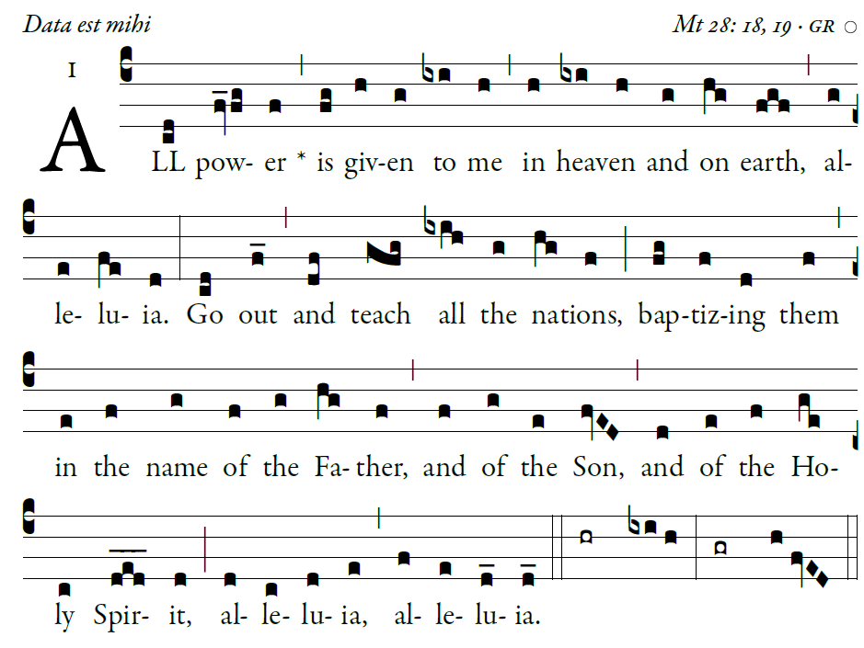

Illuminarepublications.com
Give ear, my people, to my teaching; [6]
incline your ear to the words of my mouth
The things we have heard and understood,
the things our fathers have told us,

