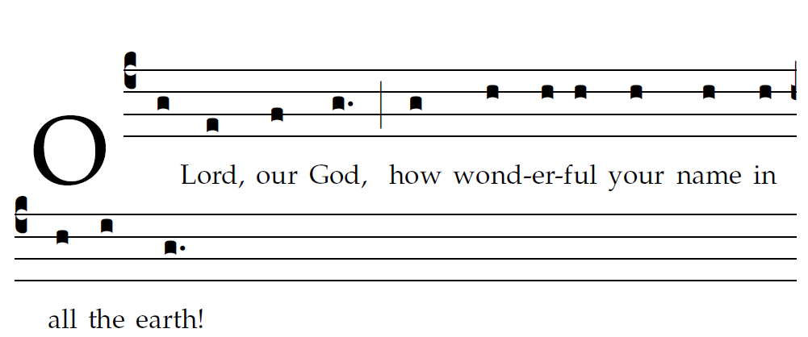

When I behold your heavens, the work of your fingers,
the moon and the stars which you set in place —
What is man that you should be mindful of him,
or the son of man that you should care for him?
You have made him little less than the angels,
and crowned him with glory and honor.
You have given him rule over the works of your hands,
putting all things under his feet:
All sheep and oxen,
yes, and the beasts of the field,
The birds of the air, the fishes of the sea,
and whatever swims the paths of the seas.

