COMMUNION HYMN

Stille Nacht
SILENT NIGHT
Stille Nacht, heilige Nacht,
Alles schläft; einsam wacht
Nur das traute hochheilige Paar.
Holder Knabe im lockigen Haar,
Schlaf in himmlischer Ruh!
Schlaf in himmlischer Ruh!
Stille Nacht, heilige Nacht,
Hirten erst kundgemacht
Durch der Engel Halleluja,
Tönt es laut von fern und nah:
Christ, der Retter ist da!
Christ, der Retter ist da!
Additional verses #69 Today’s Missal

RECESSIONAL HYMN
“Hark The Herald Angels Sing” #74 Todays Missal

THE NATIVITY OF THE LORD 2017
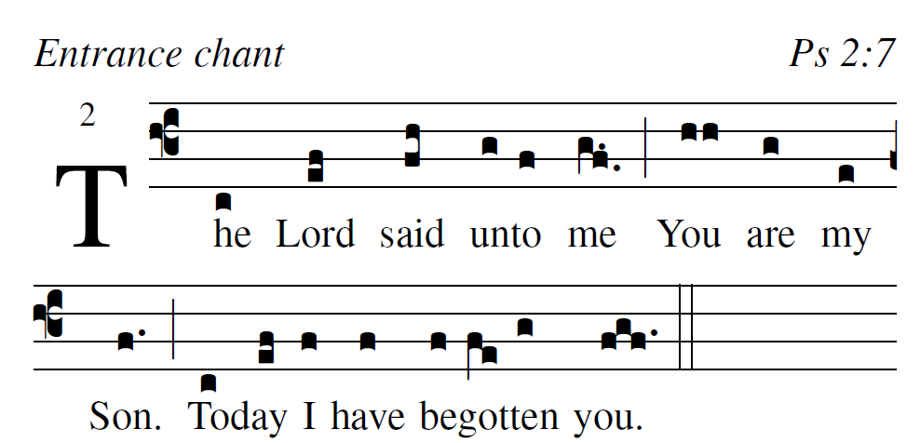

Adam Bartlet:t Simple English Propers is licensed in the Creative Commons, 2011 CMAA

Why do the nations conspire, and the peoples plot in vain?
They arise, the kings of the earth;
princes plot against the LORD and his Anointed.

Ask of me and I will give you
the nations as your inheritance,
and the ends of the earth as your possession

With a rod of iron you will rule them;
like a potter’s jar you will shatter them.”.
So now, O kings, understand;

Ordinary From Mass Of Pope St John Paul By Richard Clark
See other program
RESPONSORIAL PSALM
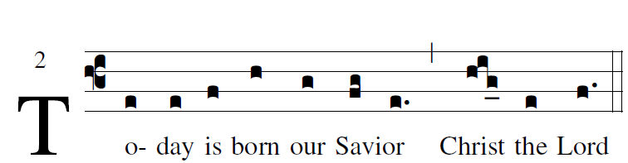

Creative Commons Copyright © 2010 The st. Noel Chabanel Responosrial Psalm Project*

Sing to the LORD a new song;
sing to the LORD, all you lands.
Sing to the LORD; bless his name.
Announce his salvation, day after day.
Tell his glory among the nations;
among all peoples, his wondrous deeds.
Let the heavens be glad and the earth rejoice;
let the sea and what fills it resound;
let the plains be joyful and all that is in them!
Then shall all the trees of the forest exult.
They shall exult before the LORD, for he comes;
for he comes to rule the earth.
He shall rule the world with justice
and the peoples with his constancy.

ALLELUIA
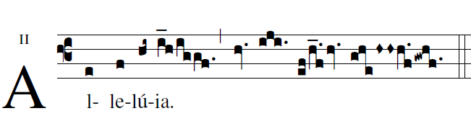
I proclaim to you good news of great joy:
today a Savior is born for us,Christ the Lord.

OFFERTORY HYMN

“Of The Father’s Love Begotten” Today’s Missal #66

COMMUNION

In the splendor of holiness I have brought you forth. Before the dawn I have begotten you.

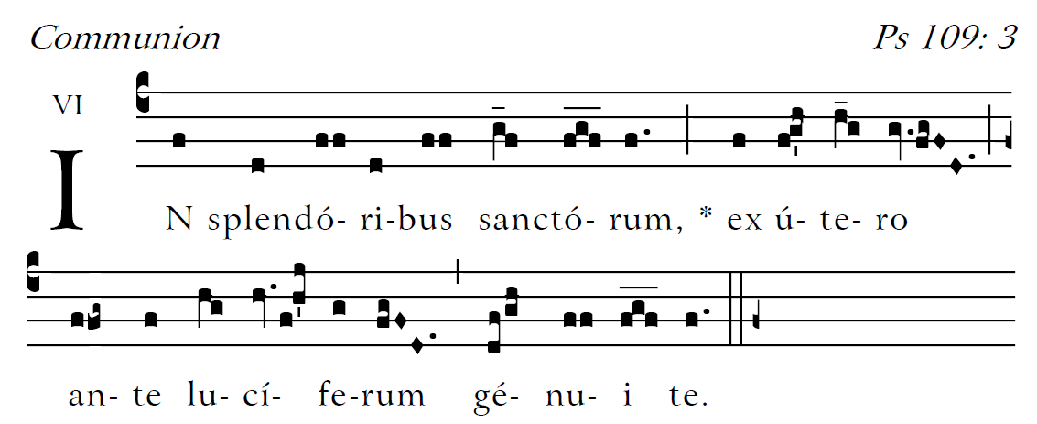

The Lord’s revelation to my lord:
“Sit at my right hand,
until I make your foes your footstool.”

The Lord will send from Sion
your scepter of power:
rule in the midst of your foes
With you is princely rule
on the day of your power.

In holy splendor, from the womb before the dawn,
I have begotten you.
The lord has sworn an oath he will not change:

Continue with communion hymn: next page

